Salzburg/Austria, February 19, 2024
87 million euros: COPA-DATA increases turnover by a quarter
Software company COPA-DATA closed the 2023 financial year with impressive sales growth of around 25%. With key topics such as sustainability, modular production and digitalization, the company has established itself as a global partner for the manufacturing industry.
Compared to the previous year, COPA-DATA was able to increase its global Group revenue by a quarter, from EUR 69.4 million (2022) to EUR 87.0 million in 2023. For Phillip Werr, Member of the Management Board, this success is the result of the joint efforts of all colleagues: "The new sales record shows us that more users worldwide are relying on our software than ever before. This is a great endorsement for all our employees, who are committed to the success of our customers every day!"
Expansion and personnel growth
In 2023, COPA-DATA created further new jobs and now employs more than 400 people in Austria and at its branches worldwide, which corresponds to a growth of ten percent compared to the previous year.
300,000 can't be wrong
The impact that COPA-DATA is making towards a more sustainable planet can be seen in the efficiency gains on the customer side. Energy savings by large corporations, for example, mean a lot of CO₂ saved. In total, over 300,000 installations of the zenon software platform are in use in industrial companies and the energy sector worldwide. Last year alone, the software manufacturer sold more than 30,000 licenses.

In order to strengthen its expertise in the area of sustainability, COPA-DATA expanded its industrial management team for F&B in 2023 to including sustainability solutions. Led by Emilian Axinia, an expert with over 25 years of experience in industrial automation, the team develops cross-industry solutions to support manufacturing companies on their journey to Net Zero.
COPA-DATA is also focusing on sustainability internally, for example by further optimizing the energy consumption of its office building at its headquarters in Salzburg, which was built in 2022, with its zenon software platform. Sustainability initiatives also include the global subsidiaries. Since 2023, all COPA-DATA locations worldwide have been CO₂-compensating. This means that greenhouse gas emissions are fully offset by supporting environmental projects. These efforts have been recognized for the entire Group through certification as a climate protection partner by ClimatePartner.
Associate Partner of the World Economic Forum
COPA-DATA is convinced that innovative technical approaches are essential for overcoming global challenges, and that the energy transition will only succeed if everyone pulls together and works together across countries and industries. As an Associate Partner, the company took part in the World Economic Forum (WEF) in Davos for the second time to explore possibilities for reducing CO2 emissions and increasing efficiency in production and infrastructure with top representatives of global corporations.
Prospects for younger generations
In addition to the economic and environmental aspects, sustainability also means a social commitment to future generations. Against this background, the training of young employees is also a concern of COPA-DATA. This is also recognized outside the company: The Salzburg Chamber of Commerce recognized COPA-DATA as the best training company in 2023. This underlines COPA-DATA's continuous efforts not only to train qualified specialists for its own industry but also to contribute to the development of the regional economy and community.

Next generation takes responsibility
With CEO and founder Thomas Punzenberger’s sons Felix and Lukas taking on responsibility in the family business COPA-DATA, the next generation has stepped up. Lukas Punzenberger, as Director of Product Management, is driving the development of zenon and presented his visions for the coming years at the annual zenon rocks event. Felix Punzenberger, as Team Lead, heads up the Professional Services, Content & Templates team.
Captions:
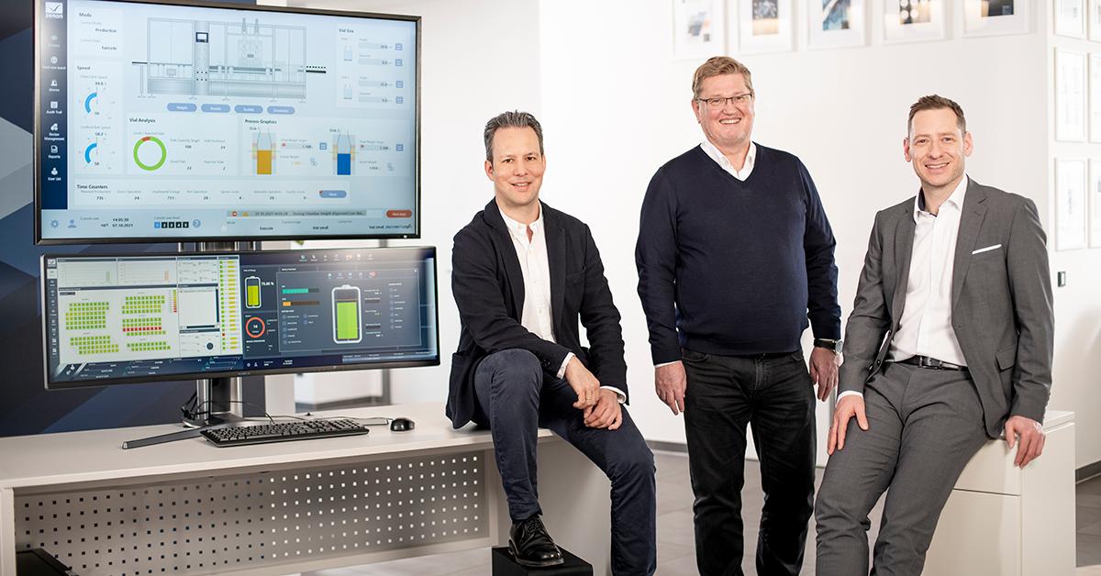
Executive_board_COPA-DATA_HQ.jpg: Members of the Management Board Phillip Werr; CEO and founder Thomas Punzenberger and CSO Stefan Reuther are proud of the successful annual financial statement (from left).
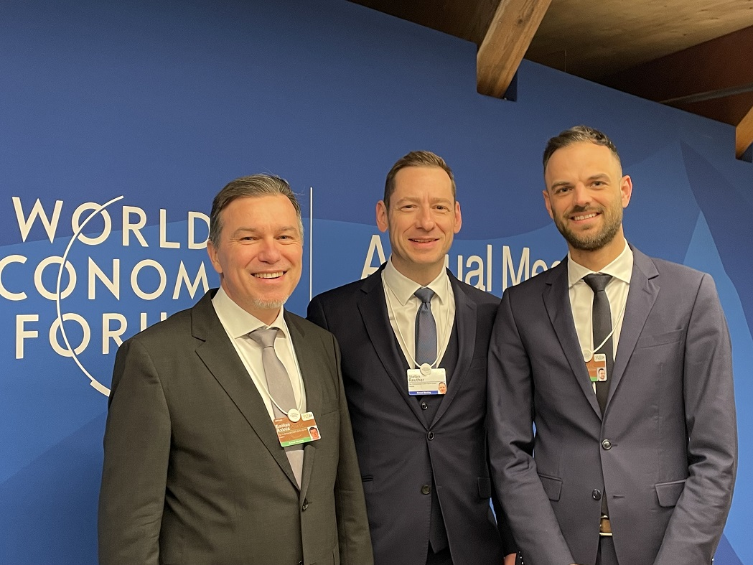
WEF-Davos_COPA-DATA_2024.jpg: Sustainability manager Emilian Axinia, Stefan Reuther, Member of the Executive Board und VP Global Business Development Christoph Dorigatti at the World Economic Forum in Davos (from left).

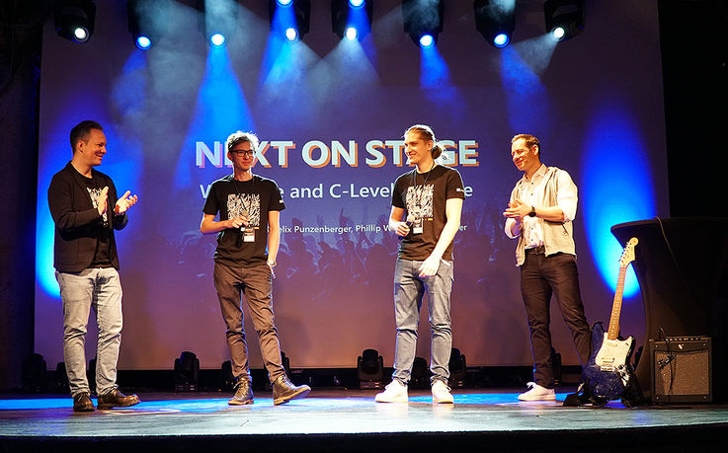
Lukas_Felix_Punzenberger.jpg: Lukas and Felix Punzenberger (middle) on the stage of zenon rocks together with Phillip Werr and Stefan Reuther, Members of the Executive Board (from left).

About COPA-DATA
COPA-DATA is an independent software manufacturer that specializes in digitalization for the manufacturing industry and energy sector. Its zenon® software platform enables users worldwide to automate, manage, monitor, integrate and optimize machines, equipment, buildings and power grids. COPA-DATA combines decades of experience in automation with the potential of digital transformation. In this way, the company supports its customers to achieve their objectives more easily, faster and more efficiently.
The family-owned business was founded by Thomas Punzenberger in 1987 in Salzburg, Austria. In 2023, with more than 400 employees worldwide, it generated revenue of EUR 87 million.
Your contact persons:
Robert Korec
PR & Communications Consultant
+43 662 43 10 02 – 296
Robert.Korec@copadata.com

Sebastian Bäsken
Team Lead Marketing Communications
+43 662 43 10 02 – 345
Sebastian.Baesken@copadata.com

Ing. Punzenberger COPA-DATA GmbH
(COPA-DATA Headquarters)
Karolingerstr. 7b
5020 Salzburg
Austria
www.copadata.com

