Salzburg/Austria, January 17, 2024
SEP Becomes First Gold Partner from Saudi Arabia in COPA-DATA Partner Community
SEP, a respected solution provider based in Saudi Arabia, has achieved the esteemed Gold Partner status within the COPA-DATA Partner Community. Building on its prior Silver Partner status, SEP is now the first Gold Partner in Saudi Arabia.
SEP specializes in offering comprehensive automation and smart solutions to businesses in the Energy, Oil and Gas Industries. Enjoying a strong partnership with COPA-DATA and years of experience working with the company’s zenon software platform, SEP has been able to elevate its status to that of Gold Partner.
Commitment to efficiency and reliability in the power supply sector
SEP's expertise lies in the areas of system engineering in the energy sector, which enables the company to provide state-of-the-art solutions that ensure efficiency and a reliable power supply. With a team of 400 qualified professionals, SEP offers complete energy automation solutions for end users in the energy supply sector.
Leveraging the power of COPA-DATA's zenon software platform
Under the leadership of Dr. Bruno Stocchi, General Manager at SEP, the company has successfully delivered automation solutions to customers across Saudi Arabia. Niaz Hussain Panhwar, Business Development Manager at SEP, emphasizes the importance of zenon in creating these systems: "The software is what brings the systems to life. As a service provider, we need a platform that offers comprehensive functions and easy adaptability to different application scenarios."

SEP's journey to Gold Partnership
SEP's commitment to excellence and its proficiency in leveraging COPA-DATA's zenon software platform has earned it the coveted Gold Partner status. Having initially become a COPA-DATA Qualified Partner in 2017, SEP's promotion to Gold Partner in 2023 demonstrates its continued dedication to excellence.
COPA-DATA congratulates SEP on its achievement and looks forward to deepening the partnership. This collaboration reflects our shared commitment to delivering innovative automation solutions in Saudi Arabia.
For further information about SEP and its offerings, please visit https://sep.com.sa/

Caption:
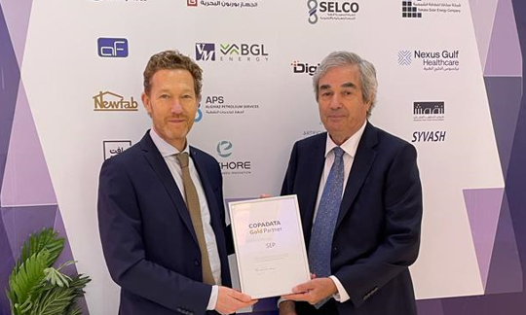
Gold partnership_SEP.jpg
Bruno Stocchi (right), General Manager of SEP, received the certificate at the Saudi Arabia Smart Grid Conference from COPA-DATA CEE/ME President Alexander Punzenberger (left).

About COPA-DATA
COPA-DATA is an independent software manufacturer that specializes in digitalization for the manufacturing industry and energy sector. Its zenon® software platform enables users worldwide to automate, manage, monitor, integrate and optimize machines, equipment, buildings and power grids. COPA-DATA combines decades of experience in automation with the potential of digital transformation. In this way, the company supports its customers to achieve their objectives more easily, faster and more efficiently. The family-owned business was founded by Thomas Punzenberger in 1987 in Salzburg, Austria.
Your contact person:
Susanna Jankovic
International Marketing Manager
Susanna.Jankovic@copadata.com
Tel.: 0662 431 002-250

COPA-DATA GmbH Central Eastern Europe/Middle East
Karolingerstrasse 7b
A-5020 Salzburg
www.copadata.com

