Salzburg/Austria, March 1, 2023
69 million euros: COPA-DATA tops sales record
COPA-DATA closed 2022 with a year-on-year revenue increase of 8.4 percent. Revenue drivers include transformation towards sustainable production and ever-advancing digitalization.
COPA-DATA is sustainably on the road to success. As in previous years, the industrial software company again increased its global group revenue in 2022. With a sales increase of 8.4 percent, 2021’s record result of 64 million euro turnover was exceeded by a 2022 total of 69.4 million euros.
With its zenon software platform, COPA-DATA supports industrial companies, including the science and technology group Merck, Carlsberg Srbija, and energy suppliers such as Salzburg AG with its simple and secure automation. zenon integrates machines, plant components and control systems from a wide range of manufacturers so that plants can be operated efficiently and flexibly.
To drive its continued success, company founder and CEO Thomas Punzenberger relies on independence and organic growth instead of outside investors, both at company headquarters and internationally. Growth always comes with a question of how to attract new talent. As in previous years, the COPA-DATA team grew in 2022. The company now employs more than 350 people worldwide.

International growth strategy
COPA-DATA also expanded its international presence and its worldwide distributor network in the past year, including in Southeast Asia and Chile. The South American market, with its pioneering role in the photovoltaic sector, is one of the regions with the highest growth rates for renewable energies.
Success through sustainability
The topic of sustainability has arrived at most industrial companies in 2022 and has become a central component of growth strategy for the coming years. COPA-DATA offers a software platform which sets the course toward sustainability and drives energy sector transformation by means of digitalization. Phillip Werr, COO and member of the management board, stated: "With zenon, our customers create transparency and efficiency in their production processes. In addition, we simplify the use of renewable energies in energy networks and manufacturing."
Implementing CO2 neutrality
COPA-DATA not only wants to support industrial companies in making their production more efficient and sustainable, but also consistently lives these values in its own company. The completion of a second office building near the company headquarters in summer 2022 was an important milestone in this direction. An innovative building management system based on the company's own zenon software platform, in conjunction with a powerful PV system, makes it possible to make the best possible use of the energy generated. "We also want to set new standards in our own company and use our expertise to demonstrate new solutions," said company founder and CEO Thomas Punzenberger. Through these advances combined with offsetting services, the company has already achieved climate neutrality at its headquarters by 2022. By mid-2023, the entire group, including its worldwide subsidiaries, is expected to follow suit.
Into the new year as a global innovator at Davos
Climate neutrality in production is becoming increasingly important (Net Zero Manufacturing). It was one of the main topics at the World Economic Forum at the beginning of the new year. For Executive Board member Stefan Reuther, who was invited to the meeting in Davos for the first time, it is a strong signal towards the future: "The fact that COPA-DATA was the only Austrian company to be part of the Global Innovators Community illustrates that the contribution which digitalization can make to climate change is receiving a great deal of attention from the most important decision-makers in the global economy. It also proves that companies with a high level of technical expertise are trusted to provide the decisive impetus here, regardless of their size."

Caption:
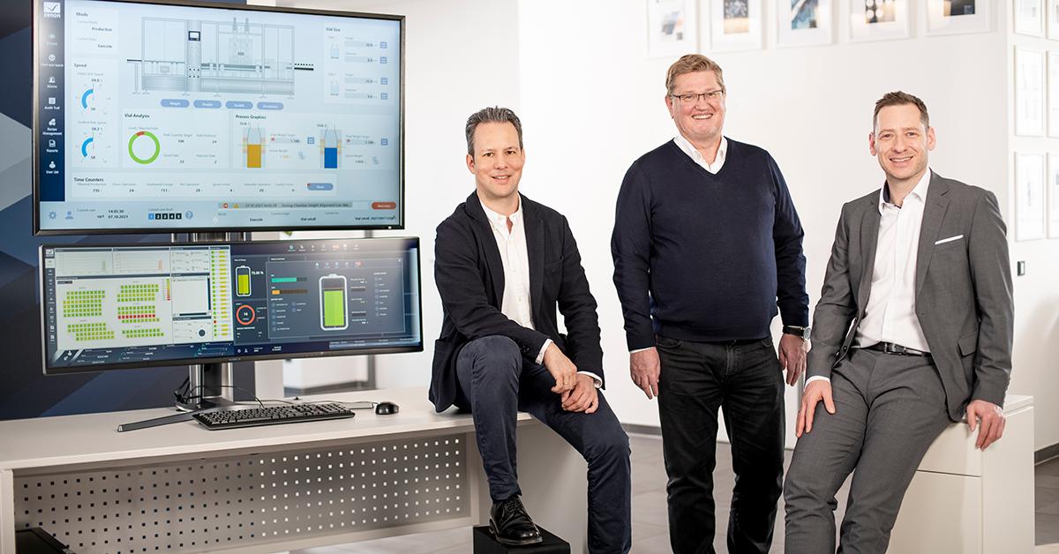
Executive_board_COPA-DATA_HQ_2022.jpg: CMO Phillip Werr, CEO and founder Thomas Punzenberger, and CSO Stefan Reuther (from left) are pleased with a successful financial year.
About COPA-DATA
COPA-DATA is an independent software manufacturer that specializes in digitalization for the manufacturing industry and energy sector. Its zenon® software platform enables users worldwide to automate, manage, monitor, integrate and optimize machines, equipment, buildings and power grids. COPA-DATA combines decades of experience in automation with the potential of digital transformation. In this way, the company supports its customers to achieve their objectives more easily, faster and more efficiently.
The family-owned business was founded by Thomas Punzenberger in 1987 in Salzburg, Austria. In 2022, with more than 350 employees worldwide, it generated revenue of EUR 69 million.
Your contact persons:
Robert Korec
PR & Communications Consultant
+43 662 43 10 02 – 296
Robert.Korec@copadata.com

Sebastian Bäsken
Marketing Communications Manager
+43 662 43 10 02 – 345
Sebastian.Baesken@copadata.com

Ing. Punzenberger COPA-DATA GmbH
(COPA-DATA Headquarters)
Karolingerstr. 7b
5020 Salzburg
Austria
www.copadata.com

