Salzburg/Austria, September 1, 2022
Alpine-Andean Alliance
Fabelec new zenon distributor
COPA-DATA, a developer of industrial automation software based in Salzburg, Austria, is expanding its global distributor network and strengthening its presence in Latin America. With Chilean automation professional Fabelec, the provider of the zenon software platform has found the perfect partner to serve customers locally.
The COPA-DATA distributor network, which covers five continents, previously consisted of sixteen companies. With distributor number seventeen, Fabelec from Chile, the Salzburg software developers have now succeeded in bringing on board a company that, like COPA-DATA, has been able to build up more than 35 years of experience in the automation of industrial production plants.
Chile as an important growth market
For Stefan Reuther, Chief Sales and Services Officer, the cooperation is another milestone in COPA-DATA's growth strategy: "Chile is one of our focus markets in Latin America. Initially, the focus will be on inspiring the existing network of system integrators with zenon, organizing joint marketing activities such as trade fairs, and supporting sales and customer service in the already established core industries. At the same time, the goal is to develop new customers and markets."
Scalability needs independence.
For Robert Bauerschmitt, CEO of Fabelec, COPA-DATA's philosophy fits perfectly with his company's strategy: "We offer our customers scalable products that guarantee a long-term solution. With this in mind, the independence of COPA-DATA is a strong selling point. With zenon, we have a powerful software platform that fully meets our customers' requirements. Our initial experiences with COPA-DATA have been very positive. This makes us confident that the collaboration will be extremely successful."
Fabelec is an established player in the field of electronic power and control equipment with a well-developed network of system integrators and decades of experience in direct sales of automation software to integrators and end users. The company offers a range of products including soft starters, variable frequency drives, control devices (PLCs) and sensors – right up to turnkey projects.
Arthur Shetko, International Sales Manager at COPA-DATA responsible for Latin America, sees significant potential for automation and digitalization in Chile: "Chile is one of the leading countries in Latin America for renewable energy. Solar and wind energy are taking up an increasingly large share of the overall power generation mix."
zenon offers a promising proposition for the Chilean market – for example, through functions for monitoring large-scale battery plants for rapid fault clearance. In addition, zenon’s automation and digitalization capabilities are well-established in serving energy-specific use cases. "With Fabelec, we have found a distributor that has an extensive network of partners and integrators and deep expertise in different industries," Shetko said.
Captions:
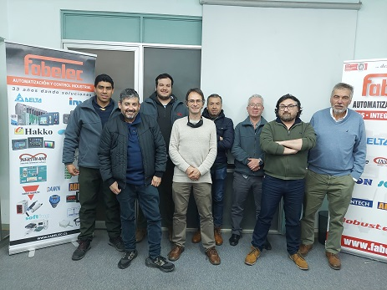
Fabelec_team.jpg: The team at Fabelec is looking forward to working with COPA-DATA.
Stefan_Reuther_COPA-DATA.jpg: Stefan Reuther, Stefan Reuther Chief Sales and Services Officer at COPA-DATA.

Arthur_Shetko_COPA-DATA.jpg: Arthur Shetko, International Sales Manager, Latin America at COPA-DATA.
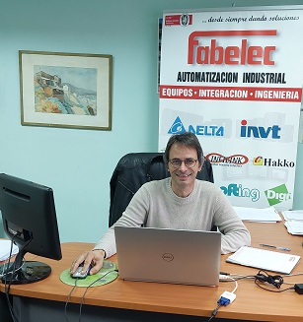
Robert_Bauerschmitt_Fabelec.jpg: Robert Bauerschmitt, CEO at Fabelec.
About COPA-DATA
COPA-DATA is an independent software manufacturer that specializes in digitalization for the manufacturing industry and energy sector. Its zenon® software platform enables users worldwide to automate, manage, monitor, integrate and optimize machines, equipment, buildings and power grids. COPA-DATA combines decades of experience in automation with the potential of digital transformation. In this way, the company supports its customers to achieve their objectives more easily, faster and more efficiently.
The family-owned business was founded by Thomas Punzenberger in 1987 in Salzburg, Austria. In 2021, with more than 300 employees worldwide, it generated revenue of EUR 64 million.
Your contact persons:
Robert Korec
PR & Communications Consultant
+43 662 43 10 02 – 296
Robert.Korec@copadata.com

Sebastian Bäsken
Marketing Communications Manager
+43 662 43 10 02 – 345
Sebastian.Baesken@copadata.com

Ing. Punzenberger COPA-DATA GmbH
(COPA-DATA Headquarters)
Karolingerstr. 7b
5020 Salzburg
Austria
www.copadata.com

www.copadata.com

