Salzburg/Austria, August 10, 2023
COPA-DATA releases zenon 12
COPA-DATA has introduced the latest version of its software platform, zenon. zenon 12 includes an enhanced, browser-independent Web Visualization Service and a natively integrated MTP suite. Additionally, new features include Linux support and an interface to SAP Netweaver.
The new version of the zenon software platform advances performance and user experience. With zenon 12, a more comprehensive Web Visualization Service (WVS) and an enhanced report engine are available. Many enhancements provide more connectivity to Linux or GraphQL.
On the way to Linux
With the new release, parts of zenon have been migrated to Linux. This increases user freedom in choosing the preferred operating system. The integration of the Data Storage Service has created the possibility to export process data to a cloud storage. Additionally, an OPC UA Gateway has been implemented to improve interoperability and data exchange between different systems. This enhancement improves integration, efficiency and security of communication and data transfer in a heterogeneous industrial environment.
Modular production
The combination of modular production and Module Type Package (MTP) offers a promising solution that is revolutionizing manufacturing processes in numerous industries. This makes it possible to make production more flexible and meet the demand for small batches and individual solutions, as well as shorten product and innovation cycles.
The cross-industry and cross-manufacturer standard MTP supports consistent modularization in production and has been natively supported in zenon since Version 11. zenon 12 considers the continuous further development of the MTP standard by supporting all newly released parts (Part 1 to 5.1), such as the Service Apply mechanism and the Service Operator interaction. To integrate older machinery and legacy equipment via MTP, the MTP Gateway offers an easy way to make these existing plants MTP-enabled using the integrated zenon Logic (IEC 61131-3 Soft-PLC). It provides the complete MTP status model, the OPC UA data structure, and all required MTP function blocks.
SAP interface
zenon 12 now uses the SAP Netweaver interface to ensure a smooth exchange of production data with the ERP level. This enables efficient communication and data transfer between production and enterprise level.
Browser-agnostic HTML5 visualization
The Web Visualization Service (WVS) offers the ability to use visually appealing and high-quality Human Machine Interface (HMI) or monitoring solutions in web browsers such as Chrome, Firefox, and Safari. The performance of the WVS has been improved by numerous extensions in zenon 12.
zenon 12 is available now. All further new features can be found here.
Images
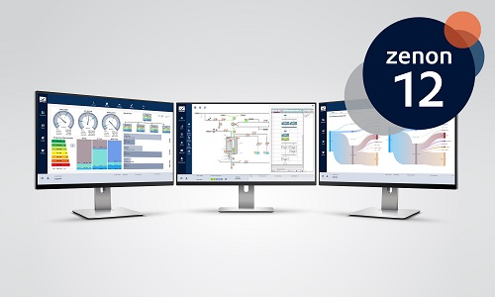
Key visual zenon 12 with logo, hi-res.
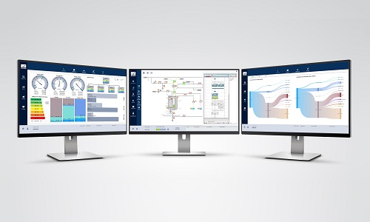
Key visual zenon 12 without logo, hi-res.

About COPA-DATA
COPA-DATA is an independent software manufacturer that specializes in digitalization for the manufacturing industry and energy sector. Its zenon® software platform enables users worldwide to automate, manage, monitor, integrate and optimize machines, equipment, buildings and power grids. COPA-DATA combines decades of experience in automation with the potential of digital transformation. In this way, the company supports its customers to achieve their objectives more easily, faster and more efficiently.
The family-owned business was founded by Thomas Punzenberger in 1987 in Salzburg, Austria. In 2022, with more than 350 employees worldwide, it generated revenue of EUR 69 million.
Your contact persons:
Robert Korec
PR & Communications Consultant
+43 662 43 10 02 – 296
Robert.Korec@copadata.com

Sebastian Bäsken
Team Lead Marketing Communications
+43 662 43 10 02 – 345
Sebastian.Baesken@copadata.com

Ing. Punzenberger COPA-DATA GmbH
(COPA-DATA Headquarters)
Karolingerstr. 7b
5020 Salzburg
Austria
www.copadata.com
COPA-DATA Melting Blog

