Press Release
Salzburg/Austria, September 15, 2026
Accelerating the path to SDA with new zenon version 16
With the new version of its software platform, zenon 16, software manufacturer COPA-DATA addresses current and future challenges in the automation of industrial production and power grids. In doing so, the global company is marking another milestone on the path toward Software-defined Automation (SDA) and the industrial automation of tomorrow.

Version 16 of the zenon software platform helps industrial companies and power grid operators make automation more flexible, secure and efficient. The new version of zenon features numerous enhanced functions for simple, modular automation, state-of-the-art cybersecurity, easy web-based use, interoperability and powerful engineering processes.

The developments come against the backdrop of the profound transformation taking place in industrial automation. Today, production facilities and critical infrastructure such as power grids not only need to become more efficient, but also adapt more quickly to changing market conditions, regulatory requirements and technological developments while meeting growing demands for cybersecurity, interoperability and data availability. Conventional plants and automation systems are increasingly reaching their limits. What is needed are open, software-based systems that enable flexible adaptation to evolving requirements without calling existing investments into question.

“With zenon 16, the software platform reaches the next important milestone on the path toward Software-Defined Automation (SDA). New functions such as biometric authentication and expanded Linux support are driving the platform’s further development. This enables our customers to master today’s challenges while preparing for tomorrow’s requirements”, says Lukas Punzenberger, Director Product Management, COPA-DATA.

Support for modular production
Software is increasingly becoming a key driver of innovation in industrial automation. Instead of closed, standalone solutions, companies are turning to flexible platforms that cover the entire lifecycle of a plant, can be adapted to new requirements without major effort and integrate seamlessly with existing systems.

With zenon 16, COPA-DATA is consistently expanding this platform approach. One focus is again on driving forward modular production concepts. By supporting the current Module Type Package (MTP) 2.0 standard zenon 16 supports cutting edge technology for modular production. New zenon Process Libraries for Rockwell as well as Mitsubishi PLC are now available for purchase in the zenon Engineering Store. These make it easier and faster to implement modular plant concepts and reduce engineering effort and potential sources of error.

In addition, zenon is expanding engineering capabilities within the Orchestration Studio with new Excel-based import and export functions as well as the automatic and simple creation of complete MTP files from an OpenDCS project. This allows changes to be implemented more quickly, and project versions to be efficiently shared internally, with customers or partners. The result is shorter project lead times, better reusability of existing plants and increased future-proofing of investments in industrial automation.

Cybersecurity as an integral part of modern automation
As production facilities become increasingly connected, cybersecurity requirements are growing, particularly in connection with secure identities and traceable user activities. Regulatory requirements are also increasing across many industries. zenon 16 addresses these challenges with a range of additional security functions. For the first time, the platform supports biometric authentication methods based on the FIDO2 standard. Users can log in, for example, via biometric wearables. This can reduce the use of passwords, simplify operating processes and at the same time increase security standards.

Within the zenon IIoT Services, a central Notification Service, an enhanced Audit Journal and improvements to the Identity Service provide greater transparency regarding security-relevant events and user activities. This gives companies tools that adequately support compliance requirements while facilitating the secure operation of critical plants.

Simplifying engineering, increasing productivity
Digitalization in industry or power grids only delivers its full benefits when it noticeably simplifies the everyday work of engineering teams and plant operators. For this reason, zenon 16 focuses not only on new technology features, but above all on more efficient workflows.

The Web Visualization Service has been comprehensively expanded and now supports numerous functions that were previously available exclusively within the Service Engine. These include eSignature, the display of PFC (“Procedure Function Chart”) recipes in batch production, the possibility to use zenon Logic on the client as well as additional visualization and operating options. This enables companies to use the web-based application much more effectively, with higher usability, and standardize operating concepts regardless of the end device.

Using data intelligently and across system boundaries
Data forms the foundation for informed decisions. COPA-DATA has therefore consistently expanded the options for integrating and using process information in zenon 16. With the new AVEVA PI Connector, historical process data can be integrated directly into zenon and used for visualization, reporting or analysis.

At the same time, new connectivity functions expand data exchange between different systems and create the basis for end-to-end data use throughout the entire plant lifecycle. In this way, zenon supports companies in making information available more quickly, breaking down data silos and enabling operational and strategic decisions to be made in a user-friendly way based on consistent data.

Innovations with added value for different industries
The new features in zenon 16 were specifically developed to address current and future requirements in different industries and to support companies in their respective transformation processes.

Industry | Added value
Energy & Infrastructure | New IEC 61850 Configurator for compliance with the requirements of IEC 61850 Edition 2.1, expanded Linux support and virtualization (vPAC) help energy utilities implement the urgently needed modernization of power grids and substations more quickly and efficiently, enabling them to develop their infrastructure in a future-proof manner.
Life Sciences & Pharma | MTP 2.0 support, biometric authentication with zenon IIoT Services, eSignature, and enhancements to batch management, as well as extensions to the PAS-X MSI interface, facilitate compliance with regulatory requirements and support modular production concepts.
Food & Beverage | Enhanced Web Visualization Service, numerous improvements in alarm management usability and optimized engineering functions help make production processes more efficient, reduce downtime and simplify daily plant operation.

“The requirements for the automation of infrastructure and industry are changing fundamentally. Today, companies need to respond more quickly to market changes, make their systems and plants more resilient and at the same time protect existing investments. With zenon 16, we offer an open software platform that makes it possible to achieve precisely this balance. It combines innovation with investment security and creates the foundation for the gradual transformation toward Software-defined Automation – regardless of existing systems or future technological changes,” says Juergen Resch, Director Industry Management Energy, COPA-DATA.

“When developing zenon 16, the central question for us was not which new functions we could add, but what concrete added value they would create for our users,” says Giuseppe Menin, Senior Director Manufacturing Industry, COPA-DATA. “Every innovation – from modular engineering and modern web technologies to biometric authentication – is intended to simplify processes, reduce engineering effort and help our customers implement their automation projects more quickly. The new functions were specifically developed to simplify the everyday work of engineering teams, plant operators and production managers while meeting GxP and cybersecurity requirements.”

Software-defined Automation as a long-term strategy
The combination of modular engineering concepts, enhanced security functions, powerful web technologies and an open integration architecture creates the conditions for automation solutions that can continuously evolve. Expanded Linux support – including comprehensive redundancy capabilities and ICCP Process Gateway support – and additional virtualization options also provide greater flexibility and user-friendliness when operating modern automation environments. At the same time, zenon supports companies in meeting regulatory requirements, making engineering processes more efficient and utilizing data across system boundaries.

Images
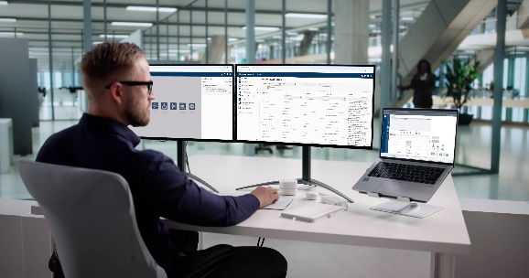
Download – image credit: Adobe Stock, Andrey Popov
With zenon 16, COPA-DATA has released the latest version of its software platform. The product’s new features and enhancements represent another step toward Software-defined Automation.
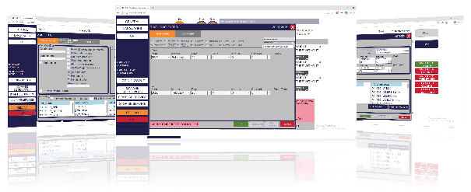
Download – image credit: COPA-DATA
New filtering options in the Web Visualization Service improve usability and provide a clearer overview of visualizations in the web browser.
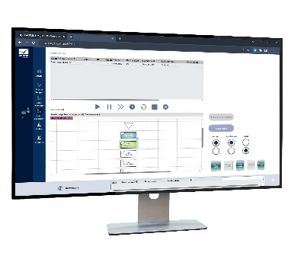
Download – image credit: COPA-DATA
PFC (“Procedure Function Chart”) batch recipes can now be viewed not only in the zenon Service Engine, but also via the Web Visualization Service.

About COPA-DATA

COPA-DATA is an independent software manufacturer that specializes in digitalization for the manufacturing industry and energy sector. Its zenon® software platform enables users worldwide to automate, manage, monitor, integrate and optimize machines, equipment, buildings and power grids. COPA-DATA combines decades of experience in automation with the potential of digital transformation and a strong drive for sustainability-enabling solutions. In this way, the company supports its customers to achieve their objectives more easily, faster and more efficiently.

You need more information?

PR Agency
Maisberger GmbH
Christine Wildgruber / Antonia Bodenschatz
Claudius-Keller-Strasse 3c
81669 Munich
Germany
copadata@maisberger.com
Tel.: +49 89 419 599-27

COPA-DATA
Ing. Punzenberger COPA-DATA GmbH
COPA-DATA Headquarters
Karolingerstrasse 7B
5020 Salzburg
Austria
www.copadata.com


