Salzburg, February 9, 2026
COPA-DATA CEE/ME 2025: Growth, Innovation and Digital Sovereignty
Industrial software is key to resilience and sustainable competitiveness
The COPA-DATA Group looks back on an exceptionally successful financial year 2025. With group-wide growth of 21 percent, the company continued its success story. In the Central and Eastern Europe and Middle East (CEE/ME) region, record revenues of EUR 12.6 million were achieved – an increase of 24.2 percent compared to the previous year. The main drivers of growth were rising demand for solutions based on the zenon software platform in the energy sector as well as in life sciences and pharma.
“Despite geopolitical challenges, 2025 was an extraordinarily successful year for COPA-DATA. This demonstrates that innovative software solutions for the manufacturing and energy industries are essential to ensuring competitiveness, resilience and digital sovereignty,” said Johannes Wolf, Managing Director of COPA-DATA CEE/ME. “Our mission is to empower companies with our zenon software platform to future-proof their processes, use resources efficiently and implement sustainable solutions. Innovation and direct value creation are always at the core of everything we do.”
Success factors: Innovation, software-defined OT and twin transition
A key growth driver was the twin transition – the simultaneous ecological and digital transformation of organizations. Industrial and energy companies are faced with the challenge of making their processes simultaneously more sustainable, efficient and resilient. Digitalization and innovation play a central role in addressing this challenge.
With its zenon software platform, COPA-DATA enables software-defined OT solutions that allow flexible, hardware-independent and centrally managed automation of production and energy processes. Especially in highly regulated industries such as life sciences and pharma, these approaches create the foundation for higher efficiency, reduced emissions and sustainable scalability.
“Automation, digitalization, sustainability and software-defined approaches are crucial to making the twin transition a long-term success,” explained Johannes Wolf. “Our no-code platform delivers direct value and helps companies align their processes in a future-proof and competitive way.”
zenonIZE 2025: International platform for innovation and exchange
One highlight of the 2025 calendar year was the global COPA-DATA event zenonIZE 2025. More than 500 international participants from over 50 countries gathered at the Mozarteum Foundation in Salzburg to exchange insights on current developments, best practices and future trends. The event offered practical insights, opportunities for discussion and high-level networking. The burgeoning attendance numbers underscore the growing importance of zenonIZE as an international platform for innovation and exchange.
International presence at the World Economic Forum in Davos
In January 2026, COPA-DATA was represented at the World Economic Forum (WEF) in Davos for the fourth time and as one of only three Austrian companies. “Participating in Davos is a special honor for us,” commented Johannes Wolf. “It allows us to contribute our expertise, identify global trends at an early stage and actively engage in dialogue with decision-makers from business and politics.”
Artificial intelligence as a strategic future topic
Artificial intelligence (AI) is a strategic future topic for COPA-DATA. The company sees great potential in using AI to make industrial processes more efficient, secure and sustainable. Initial steps have already been taken: AI use cases have been integrated into the product, strategic partnerships have been established, exchanges with other companies have been intensified and active participation in expert and working groups has been advanced.
“As a member of the AI Task Force of the Federation of Austrian Industries, I see how artificial intelligence opens up entirely new possibilities for making industrial processes smarter and more resilient. We actively support our customers in leveraging these opportunities at an early stage and implementing them in a future-proof manner,” said Johannes Wolf.

Digital sovereignty: Control and independence in industry
Digital sovereignty is about maintaining the ability to act in the digital space, reducing dependencies on major technology corporations and external players, and retaining control over one’s own data and processes, including protection against cyberattacks. Companies must understand, independently deploy and further develop key technologies in order to strengthen their resilience to geopolitical risks or technological disruptions. COPA-DATA provides this key technology, which is developed and manufactured in Austria.
Outlook for 2026
The coming year will be decisive: the cybersecurity, AI, digital sovereignty and resilience of industrial and energy companies will continue to gain importance. Companies that fail to digitalize and optimize their processes will find it increasingly difficult to remain competitive.
COPA-DATA actively supports organizations in implementing the twin transition toward a digital and green future, strengthening competitiveness and building resilience. The energy and life sciences and pharma sectors remain strategic focus areas in which the company will continue to expand its solutions.

Photo captions:

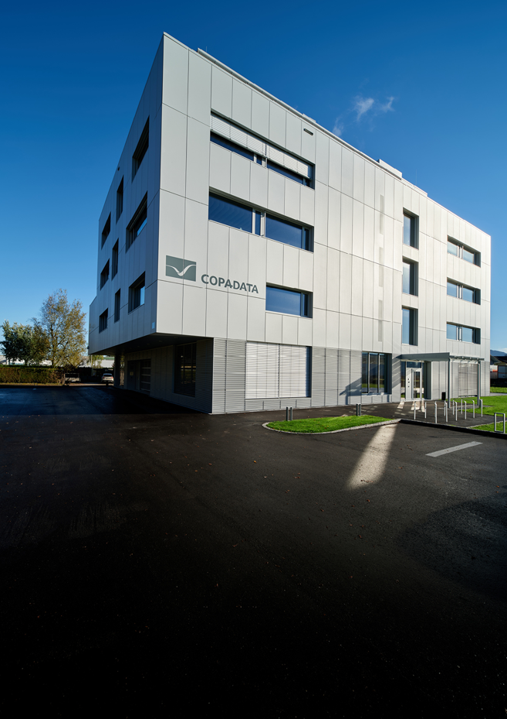
COPA-DATA_HQ.jpg
Software manufacturer COPA-DATA achieved group-wide growth of 21 percent in 2025. The company’s headquarters are located in the city of Salzburg.


COPA-DATA_Johannes Wolf.jpg
Johannes Wolf, Managing Director of COPA-DATA CEE/ME:
“Despite geopolitical challenges, 2025 was an extraordinarily successful year for COPA-DATA. This demonstrates that innovative software solutions for the manufacturing and energy industries are essential to ensuring competitiveness, resilience and digital sovereignty. Our mission is to empower companies with our zenon software platform to future-proof their processes, use resources efficiently and implement sustainable solutions. Innovation and direct value creation are always at the core of everything we do.”
About COPA-DATA
COPA-DATA is an independent software manufacturer that specializes in digitalization for the manufacturing industry and energy sector. Its zenon software platform enables users worldwide to automate, manage, monitor, integrate and optimize machines, equipment, buildings and power grids. COPA-DATA combines decades of experience in automation with the potential of digital transformation and a strong drive for solutions that achieve greater sustainability. In this way, the company supports its customers to achieve their objectives more easily, faster and more efficiently. The family-owned business was founded by Thomas Punzenberger in 1987 in Salzburg, Austria.
Your contact:
Susanna Jankovic
Head of International Marketing
Susanna.Jankovic@copadata.com
Phone: 0662 431 002-250

COPA-DATA GmbH Central Eastern Europe/Middle East
Karolingerstrasse 7b
A-5020 Salzburg
www.copadata.com




