Salzburg/Austria, November 18, 2024
COPA-DATA and obion GmbH strengthen partnership for equipment operation
With the introduction of new connection options for obion GmbH's LogOnPlus software to COPA-DATA's zenon software platform, companies in regulated industries such as life sciences benefit from a significant increase in efficiency and optimized operating processes.
LogOnPlus is a user-friendly solution from obion GmbH that enables personalized login processes for production-related applications such as MES, DCS or SCADA. Employees in production can use RFID factory ID cards to quickly and easily log in to the respective target systems, which significantly reduces the manual effort required to enter access data. This solution is based on obion GmbH's decades of experience in the development of process software for highly regulated industries.
Seamless integration with zenon and extended flexibility
With the new LogOnPlus REST Connector and the associated zenon interface, users benefit from simplified integration of RFID cards in conjunction with an Active Directory, enabling convenient login to zenon projects with minimal configurations. In addition to the classic zenon Service Engine, LogOnPlus now also supports the HTML5-based zenon client variants in order to work browser-independently on so-called thin clients or mobile end devices.
“Users can use their employee ID cards to log in to zenon projects quickly and securely using LogOnPlus. Such integration not only improves user-friendliness, but also increases security through synchronization with existing Active Directory policies”, explains Bernhard Korten, Director Life Sciences & Process Industry at COPA-DATA.

Added value for companies and employees
The simple parameterization and quick login in zenon projects offer clear advantages for the user experience. “Companies that integrate LogOnPlus into their production processes see a noticeable improvement in employee satisfaction. Logon processes, which are often perceived as cumbersome, are considerably simplified and accelerated by LogOnPlus”, explains Ralf Kühnel, Business Development Manager Products at obion GmbH.
In a highly regulated environment, every machine operation must be documented and recorded electronically. Confirmations must also be verified by the user. This can lead to multiple login-logout situations within a very short time. With LogOnPlus and the corresponding RFID card legitimization, these login situations can be significantly simplified without neglecting the security of the process.
Expansion of the long-standing partnership
The login process in zenon, which is greatly accelerated by LogOnPlus, has already been supported for several years by the existing LogOnPlus Connector for the conventional zenon Service Engine. The introduction of the new LogOnPlus REST Connector and the associated zenon interface for HTML5 applications in June 2024 marks the next step in the successful collaboration between the two companies to meet the requirements of modern production environments. “With the new interface between zenon and LogOnPlus, we can better respond to the diverse HMI operating concepts of our customers and optimally support their requirements. We are delighted to have a reliable partner at our side in COPA-DATA, which enables us to create added value for our customers together”, concludes Thomas Häuser, Managing Director Products at obion GmbH.

Caption:
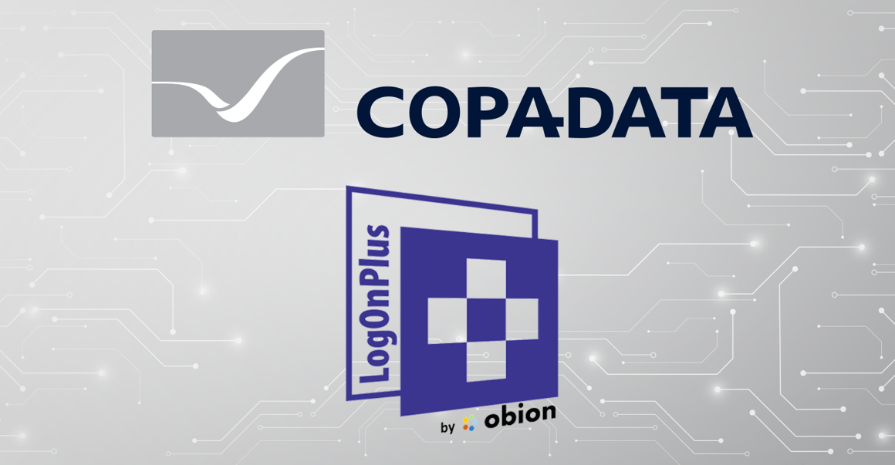
Image 1: COPA-DATA and obion GmbH strengthen partnership for equipment operation
The integration of LogOnPlus into the zenon software platform improves efficiency in regulated industries and enables faster and easier log-in for production employees via RFID cards. This leads to improved user-friendliness and security.

Image 2: Portrait of Bernhard Korten
“Users can use their employee ID cards to log in to zenon projects quickly and securely using LogOnPlus”, Bernhard Korten, Director Life Sciences & Process Industry at COPA-DATA.


Image 3: Portrait of Ralf Kühnel
“LogOnPlus considerably simplifies and speeds up login processes that are often perceived as cumbersome”, Ralf Kühnel, Business Development Manager Products at obion GmbH.

Figure 4: Portrait of Thomas Häuser
“With the new interface between zenon and LogOnPlus, we can respond better to the diverse HMI operating concepts of our customers and optimally support their requirements”, Thomas Häuser, Managing Director Products at obion GmbH.

About obion GmbH
LogOnPlus is a product of obion GmbH, the successor organization to i.p.a.s.-systeme, which has decades of experience in the field of industrial software development. obion's customers are primarily from the (bio)pharmaceutical and chemical industries. The team behind obion specializes in applications and services at the interfaces of production-relevant systems such as MES and DCS as well as in the area of process data acquisition and reporting. In 2014, the product LogOnPlus emerged from a project, which now helps to make everyday production easier at hundreds of stations.

About COPA-DATA
COPA-DATA is an independent software manufacturer that specializes in digitalization for the manufacturing industry and energy sector. Its zenon® software platform enables users worldwide to automate, manage, monitor, integrate and optimize machines, equipment, buildings and power grids. COPA-DATA combines decades of experience in automation with the potential of digital transformation and a strong drive for sustainability-enabling solutions. In this way, the company supports its customers to achieve their objectives more easily, faster and more efficiently. The family-owned business was founded by Thomas Punzenberger in 1987 in Salzburg, Austria. In 2023, with more than 400 employees worldwide, it generated revenue of EUR 87 million.
Your contact persons:
Sebastian Bäsken
Team Lead Communication & Brand
+43 662 43 10 02-345
Sebastian.Baesken@copadata.com

Samuel Inwinkl
Public Relations Consultant
+43 662 43 10 02-243
Samuel.Inwinkl@copadata.com

Ing. Punzenberger COPA-DATA GmbH
(COPA-DATA Headquarters)
Karolingerstr. 7b
5020 Salzburg
Austria
www.copadata.com





