Salzburg, July 31, 2025

COPA-DATA achieves highest level in Körber partner program "PAS-X MSI Plug & Produce"

[*Körber*](https://www.koerber-pharma.com/) *has awarded COPA-DATA the "PAS-X MSI Plug & Produce Certified" certificate for its* [*zenon software platform*](https://www.copadata.com/en/products/zenon-software-platform-for-industrial-automation-energy-automation/)*. Following the "PAS-X MSI Plug & Produce Ready" certification of zenon in 2023, COPA-DATA has now achieved the highest level of the partner program. This was achieved on the basis of a customer project.*

The "PAS-X MSI Plug & Produce" certificate is awarded to Körber partners who offer a standardized interface to their Manufacturing Execution System (MES) PAS-X MES: PAS-X MSI. The message-based shopfloor integration interface enables the simple connection of machines. The zenon no-code platform implements this standard and transfers the associated machine data to the MES. The entry-level "Ready" certificate confirms a basic understanding of this technology. The second and highest level is "Certified". It goes one step further, demonstrating that the partner company has implemented an interface and successfully participated in an interface acceptance test.

Many years of cooperation  
Giuseppe Menin, Director Life Sciences & Process Industry at COPA-DATA said: "We are delighted with the certificate. It confirms that, together with Körber, we offer our customers in the pharmaceutical industry a versatile and reliable solution." COPA-DATA has already been working with Körber for several years, including as part of the international specialist network ISPE Pharma 4.0. This network focuses on the digitalization of the highly regulated life sciences sector. Lars Hornung, Sr. Principal Alliances & Technology Partners Software in the Körber Business Area Pharma commented: "Achieving the Certified Level is good news for our joint customers, for whom the integration of zenon and PAS-X MES is on the agenda as part of the digital transformation."

Joint contribution for the future  
The industrial control software PAS-X MES monitors and documents production in real time. The interface to the zenon software platform has proven particularly successful in the integration of field equipment in the pharmaceutical sector. Using the MSI interface implemented by COPA-DATA, machines can be integrated according to the "plug & produce" principle. Menin added: "Thanks to this interface, we enable bidirectional communication between MES and production – including exception handling. This allows ‘Review by Exception’ and thus reduces the batch release time."

*Further information on the zenon MSI interface* [*can be found on the COPA-DATA website.*](https://www.copadata.com/en/industries/life-sciences-pharmaceutical/pharmaceutical-insights/zenon-msi-interface/)

About COPA-DATA  
COPA-DATA is an independent software manufacturer in the field of digitalization in the manufacturing and energy industries. With the zenon software platform, machines, equipment, buildings and power grids are automated, controlled, monitored, networked and optimized worldwide. COPA-DATA combines decades of experience in automation with the possibilities of digital transformation and a strong drive for solutions that achieve greater sustainability. As a result, the company helps its customers to achieve their goals more easily, quickly and efficiently. In 2024, the family business founded in Salzburg in 1987 by Thomas Punzenberger generated sales of 99 million euros with its 450 employees worldwide.

About Körber

"Delivering the difference in pharma": In the Körber Business Area Pharma, Körber delivers the difference by supporting its customers with a holistic ecosystem approach. The unique portfolio of end-to-end solutions ranges from machines - for aseptic process solutions, inspection, packaging and materials, and transportation systems - to consulting, services, software, and digital and AI-driven solutions that serve as integrating layers to drive pharmaceutical production.

Körber simplifies processes, reduces risks and accelerates time-to-market, ensuring smooth collaboration along the entire pharmaceutical and biotech value chain. With its extensive industry knowledge, Körber supports global customers in unlocking new potential. Its solutions contribute to a better quality of life for current and future generations. www.koerber-pharma.com

Pictures

Ein Bild, das Menschliches Gesicht, Person, Kleidung, Krawatte enthält.
Giuseppe Menin, Director Life Sciences & Process Industry at   
COPA-DATA, says that the certificate confirms a versatile and reliable software solution.

Picture credit: COPA-DATA

[Download](https://www.copadata.com/hubfs/Images%20Website/News%20Images/News%20Download_Images/COPA-DATA_Giuseppe_Menin.jpg)

Lars Hornung, Senior Principal Alliances & Technology Partners Software at Körber, is delighted for the joint customers.

Picture credit: Körber

[Download](https://www.copadata.com/hubfs/Images%20Website/News%20Images/News%20Download_Images/K%C3%B6rber_Lars_Hornung.jpg)

Ein Bild, das Text, Screenshot enthält.

The zenon MSI interface enables bidirectional communication between the MES and the production level.

Picture credit: COPA-DATA

[Download](https://www.copadata.com/hubfs/Images%20Website/News%20Images/News%20Content_Images_880x500px/News_Content_880x880px_PASX.png)

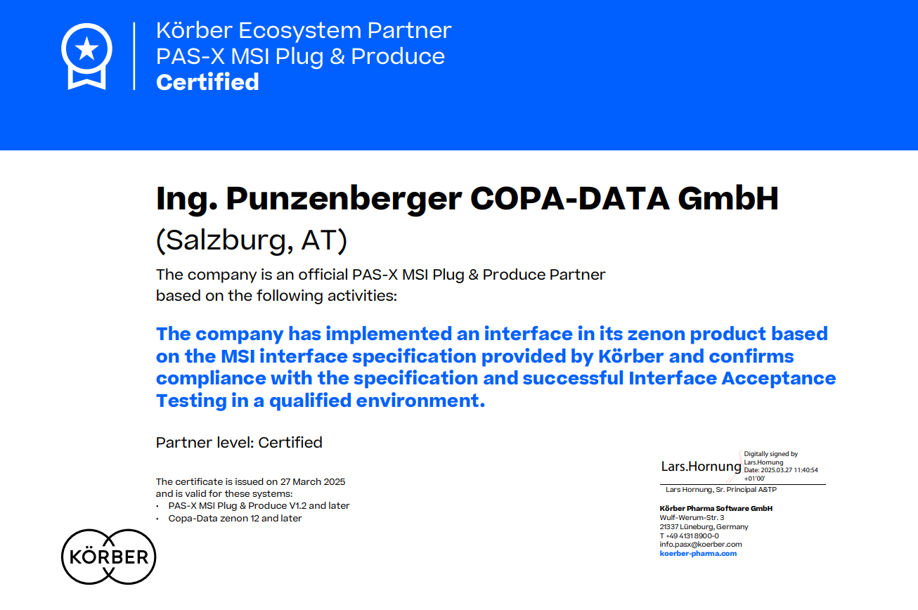Körber awards COPA-DATA with the "PAS-X MSI Plug & Produce" certificate for the zenon software platform’s simple, standardized connection to PAS-X MES.

Picture credit: COPA-DATA

[Download](https://www.copadata.com/hubfs/Images%20Website/News%20Images/News%20Download_Images/20250327-PAS-X-MSI-CopaData-CERTIFIED-sig.pdf)

Your contact persons

COPA-DATA Headquarters

Michaela Hasslacher  
Public Relations Manager  
T: +43 662 431002-242  
[michaela.hasslacher@copadata.com](mailto:samuel.inwinkl@copadata.com)

Ing. Punzenberger COPA-DATA GmbH

Karolingerstrasse 7b

5020 Salzburg

Austria

[press@copadata.com](mailto:press@copadata.com)

[www.copadata.com](http://www.copadata.com)

](https://www.instagram.com/copadata_insights/)[\\copa-data.internal\shares\User\Julia Angerer\Documents\Social Media\facebook.png](https://www.facebook.com/COPADATAHeadquarters)[\\copa-data.internal\shares\User\Julia Angerer\Documents\Social Media\youtube.png](http://www.youtube.com/user/copadatavideos)[\\copa-data.internal\shares\User\Julia Angerer\Documents\Social Media\linkedin.png](https://www.linkedin.com/company/copa-data-headquarters)

Stone Junction

Rebecca Snow

Account manager

Stone Junction Ltd

Water Street, Suites 1&2, The Malthouse

Stafford, Staffordshire, ST16 1AR

United Kingdom

T: +44 1785 225416

[becky@stonejunction.co.uk](mailto:becky@stonejunction.co.uk)

[www.stonejunction.co.uk](http://www.stonejunction.co.uk)