Princeton (NJ), October 14, 2025
RoviSys becomes COPA-DATA Gold Partner to accelerate the future of industrial automation
COPA-DATA and RoviSys are announcing a strategic partnership that marks a new chapter in the evolution of industrial automation. With RoviSys joining the COPA-DATA Partner Community's select group of official Gold Partners, the two companies are aligning their strengths to empower industries to innovate faster, operate smarter, and meet the demands of a rapidly changing world.
The partnership will deliver automation solutions that are agile, scalable, and seamlessly integrated. By combining RoviSys’ end-to-end services, including process automation, manufacturing execution systems (MES), building automation, industrial networking, and cybersecurity. With COPA-DATA’s zenon software platform, customers gain tools to modernize operations, reduce risk, and accelerate digital transformation.
“Partnering with COPA-DATA allows us to deliver solutions faster and with greater reliability in highly regulated and mission-critical industries,” said George Calvin, Director of Life Sciences at RoviSys US/Southeast Region. “COPA-DATA’s open DCS allows for a nearly endless set of use cases as the zenon software platform is hardware agnostic. It is built for rapid scale-out using Module Type Package (MTP) integration. Finally, the application support we receive from COPA-DATA is second to none.” For industries where downtime or compliance failures are not an option, this partnership delivers more than technology, it provides assurance that solutions are proven and trusted. As a Gold Partner, RoviSys gains access to exclusive COPA-DATA training, product insights, and a global knowledge base, enhancing its ability to deliver high-impact solutions. For COPA-DATA, the partnership reinforces its commitment to building a partner ecosystem centered on customer value and sustainable innovation.
“Digital transformation must deliver real outcomes – improved uptime, quality, and business value,” said Joe Salamon, Managing Director at COPA-DATA USA. “With RoviSys’ domain expertise in Life Sciences, Energy, and Metals & Mining, and their proven strength in MES and automation systems, we can apply zenon to help companies address their toughest challenges.”

RoviSys joined the COPA-DATA Partner Community in 2024 and has quickly become a key integration partner in North America. Achieving Gold Partner status within a short time highlights the depth of collaboration and the value both organizations place on the relationship. Beyond North America, RoviSys is also a Silver Partner in Asia through its Singapore office and a Bronze Partner in Europe through its Ireland office, further extending the partnership’s global reach. Serving industries such as Life Sciences, Energy, Metals & Mining, Data Centers, Chemicals, and Consumer Goods, the company develops vendor-independent automation and information solutions that support both new projects and upgrades to existing facilities.
Founded in 1989, RoviSys has decades of experience delivering automation and information systems that improve efficiency, compliance, and reliability. Its global reach and expertise in MES implementations, process control, industrial networking, and smart building systems position the company to help customers fully leverage zenon’s capabilities.
zenon, COPA-DATA’s integrated software platform, is designed to monitor, control, and optimize industrial processes with strong data integrity, secure connectivity, and efficient engineering features. It enables customers to unify operations, streamline validation, and ensure compliance across both operational and enterprise environments.

About COPA-DATA
COPA-DATA is an independent software manufacturer in the field of digitalization in the manufacturing and energy industries. With the zenon software platform, machines, equipment, buildings and power grids are automated, controlled, monitored, networked and optimized worldwide. COPA-DATA combines decades of experience in automation with the possibilities of digital transformation and a strong drive for solutions that achieve greater sustainability. As a result, the company helps its customers to achieve their goals more easily, quickly and efficiently. In 2024, the family business founded in Salzburg in 1987 by Thomas Punzenberger generated sales of 99 million euros with its 450 employees worldwide.
About RoviSys
RoviSys provides process automation, building automation, and discrete manufacturing automation solutions. With locations across North America, Asia-Pacific & Europe, we support digital transformation, industrial network solutions, artificial intelligence, and manufacturing. Industries include: Chemical, Petrochemical, Life Science, Mission Critical, Data Center, Construction, Distribution & Fulfillment, Consumer Packaged Goods, Glass, Metals, Power & Energy, Water & Wastewater, Paper & Wood, Oil & Gas, and Semiconductor.

Images
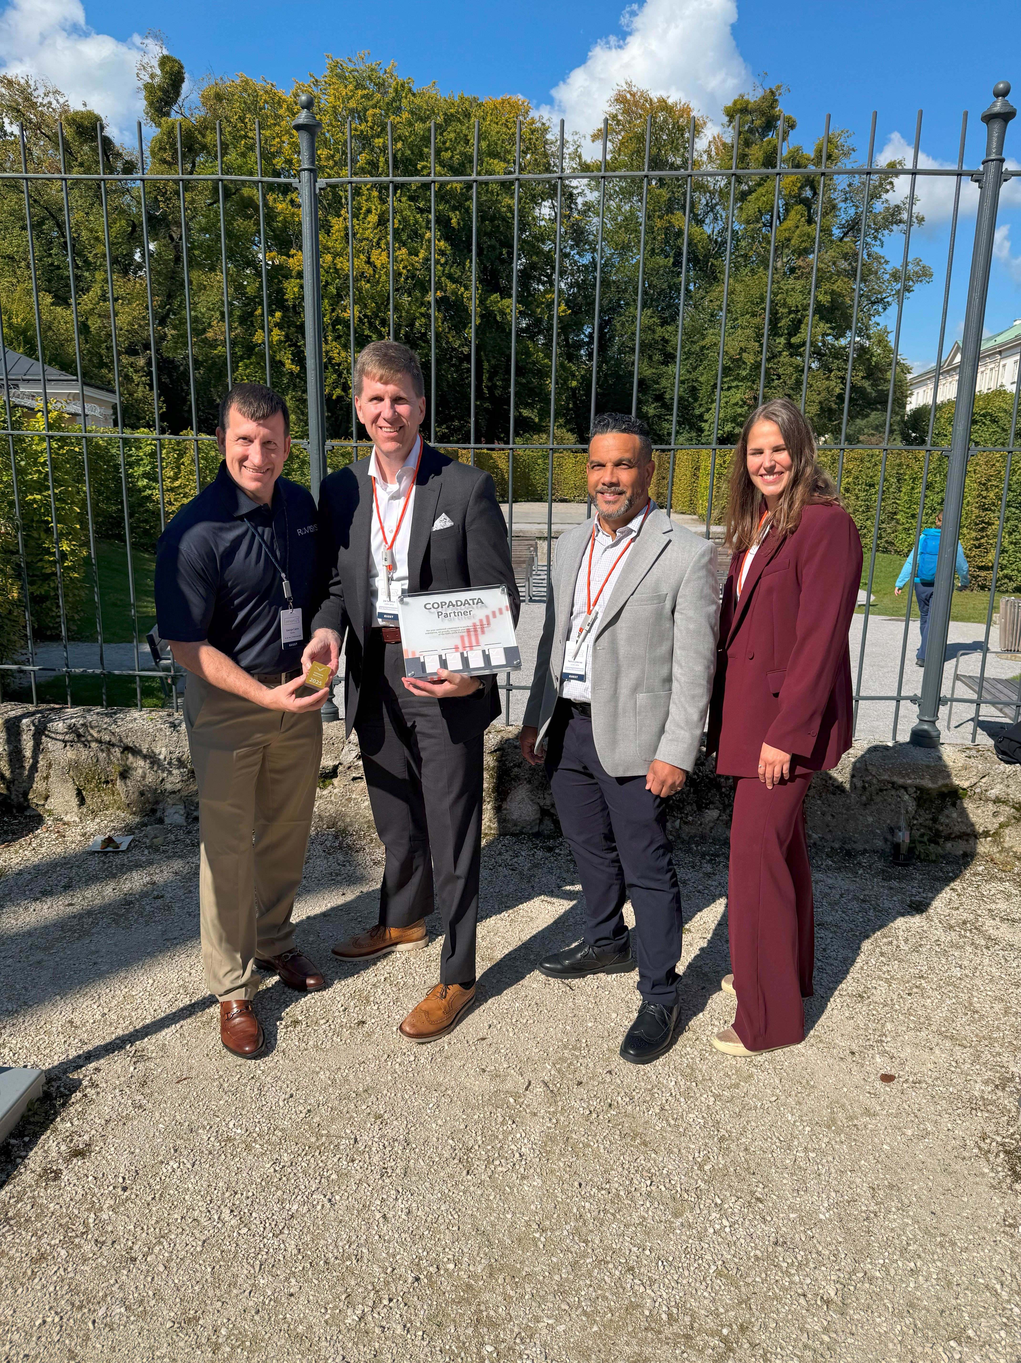
Image 1: (from left) George Calvin, Director of Life Sciences at RoviSys US/Southeast Region, Joe Salamon, Managing Director at COPA-DATA USA, Nelson Jimenez, Head of Tech at COPA-DATA USA and Verena Glück, Global Partners & Alliances at COPA-DATA Headquarters.

Download

Your contact person
COPA-DATA USA

Gabriel Carrasco
Marketing Manager
+1 (609) 299-1247
gabriel.carrasco@copadata.com

COPA-DATA USA Corp.
50 MillStone Road, Building 400, Suite 150
08520 East Windsor (NJ)
www.copadata.com





