Salzburg, July 21, 2025

COPA-DATA to exhibit at Drinktec to demonstrate how zenon enables the "Twin Transition"

Austrian software manufacturer COPA-DATA will once again be showcasing its solutions at Drinktec. The world-leading trade fair will see the beverage industry come together in Munich from September 15 to 19, 2025. COPA-DATA will be presenting in Hall 5, Stand 460 to showcase how its zenon software platform supports sustainability and digitalization.

"The world is becoming more dynamic. Companies have to react even more flexibly and quickly than before," emphasized Emilian Axinia, Director Industrial Sustainability at COPA-DATA. Axinia added, “This is true for global players as well as smaller labels and suppliers. For example, consumer demands are changing – in terms of product availability, innovation, and transparency. The challenge: these consumer demands must be reconciled with cost reduction, optimized material use and energy consumption."

Software for the “Twin Transition”  
The beverage industry is under increasing pressure. Technological development is progressing ever faster. Geopolitical conflicts, the climate catastrophe – keyword supply chain – and cyber threats are also impacting the industry. Last but not least, the need to reduce CO2 footprint plays an important role. For these reasons COPA-DATA has chosen the key theme of *Software for Your Green & Digital Transition* at Drinktec 2025. The independent, family-owned company will be presenting how its zenon software platform supports the "Twin Transition" – to progress sustainability and digitalization in the current challenging environment.

Powerful software   
COPA-DATA's presence at Drinktec (Hall 5, Stand 460) is aimed at production companies, machine manufacturers, system integrators, and other interested parties. The company’s industrial software platform, zenon, supports beverage manufacturers in areas such as real-time process monitoring, flexible process adaptation, controlling energy flows within equipment, and data-based innovation decisions. It forms the basis for the efficient use of resources, comprehensive energy management, and the development of CO₂-reduced products. Similarly, system integrators can benefit from flexible automation, a robust data infrastructure, and reduced engineering effort.

Multifaceted and yet simple  
In line with the motto *ONE platform – MANY solutions*, the software closes the gap between Information Technology (IT) and Operational Technology (OT) in a multi-faceted way. Axinia added, "zenon suits the dynamic food and beverage industry very well. The software allows solutions to be combined while always remaining simple and consistent to use."

Meeting point for the industry  
By addressing different target groups, COPA-DATA’s stand at Drinktec will be a meeting point for the entire industry. There will be numerous live demonstrations, including a presentation of the new zenon version: zenon 15. The software platform offers future-oriented technology. zenon focuses on interoperability and complies with common standards, including ISA-95, ISA-88, OMAC PackML, Weihenstephan, Namur MTP, and AAS. The success story of [Carlsberg Srbija.](https://www.copadata.com/en/success-stories/together-towards-sustainability-with-carlsberg-srbija-serbia/), for example, shows how zenon can be used in practice.

About COPA-DATA  
COPA-DATA is an independent software manufacturer in the field of digitalization in the manufacturing and energy industries. With the zenon software platform, machines, equipment, buildings and power grids are automated, controlled, monitored, networked and optimized worldwide. COPA-DATA combines decades of experience in automation with the possibilities of digital transformation and a strong drive for solutions that achieve greater sustainability. As a result, the company helps its customers to achieve their goals more easily, quickly and efficiently. In 2024, the family business founded by Thomas Punzenberger in Salzburg in 1987 generated a turnover of 99 million euros with its 450 employees worldwide.

Pictures

Emilian Axinia, Director of Industrial Sustainability at COPA-DATA, says that the zenon software platform always remains simple and consistent to use.

Picture credit: COPA-DATA

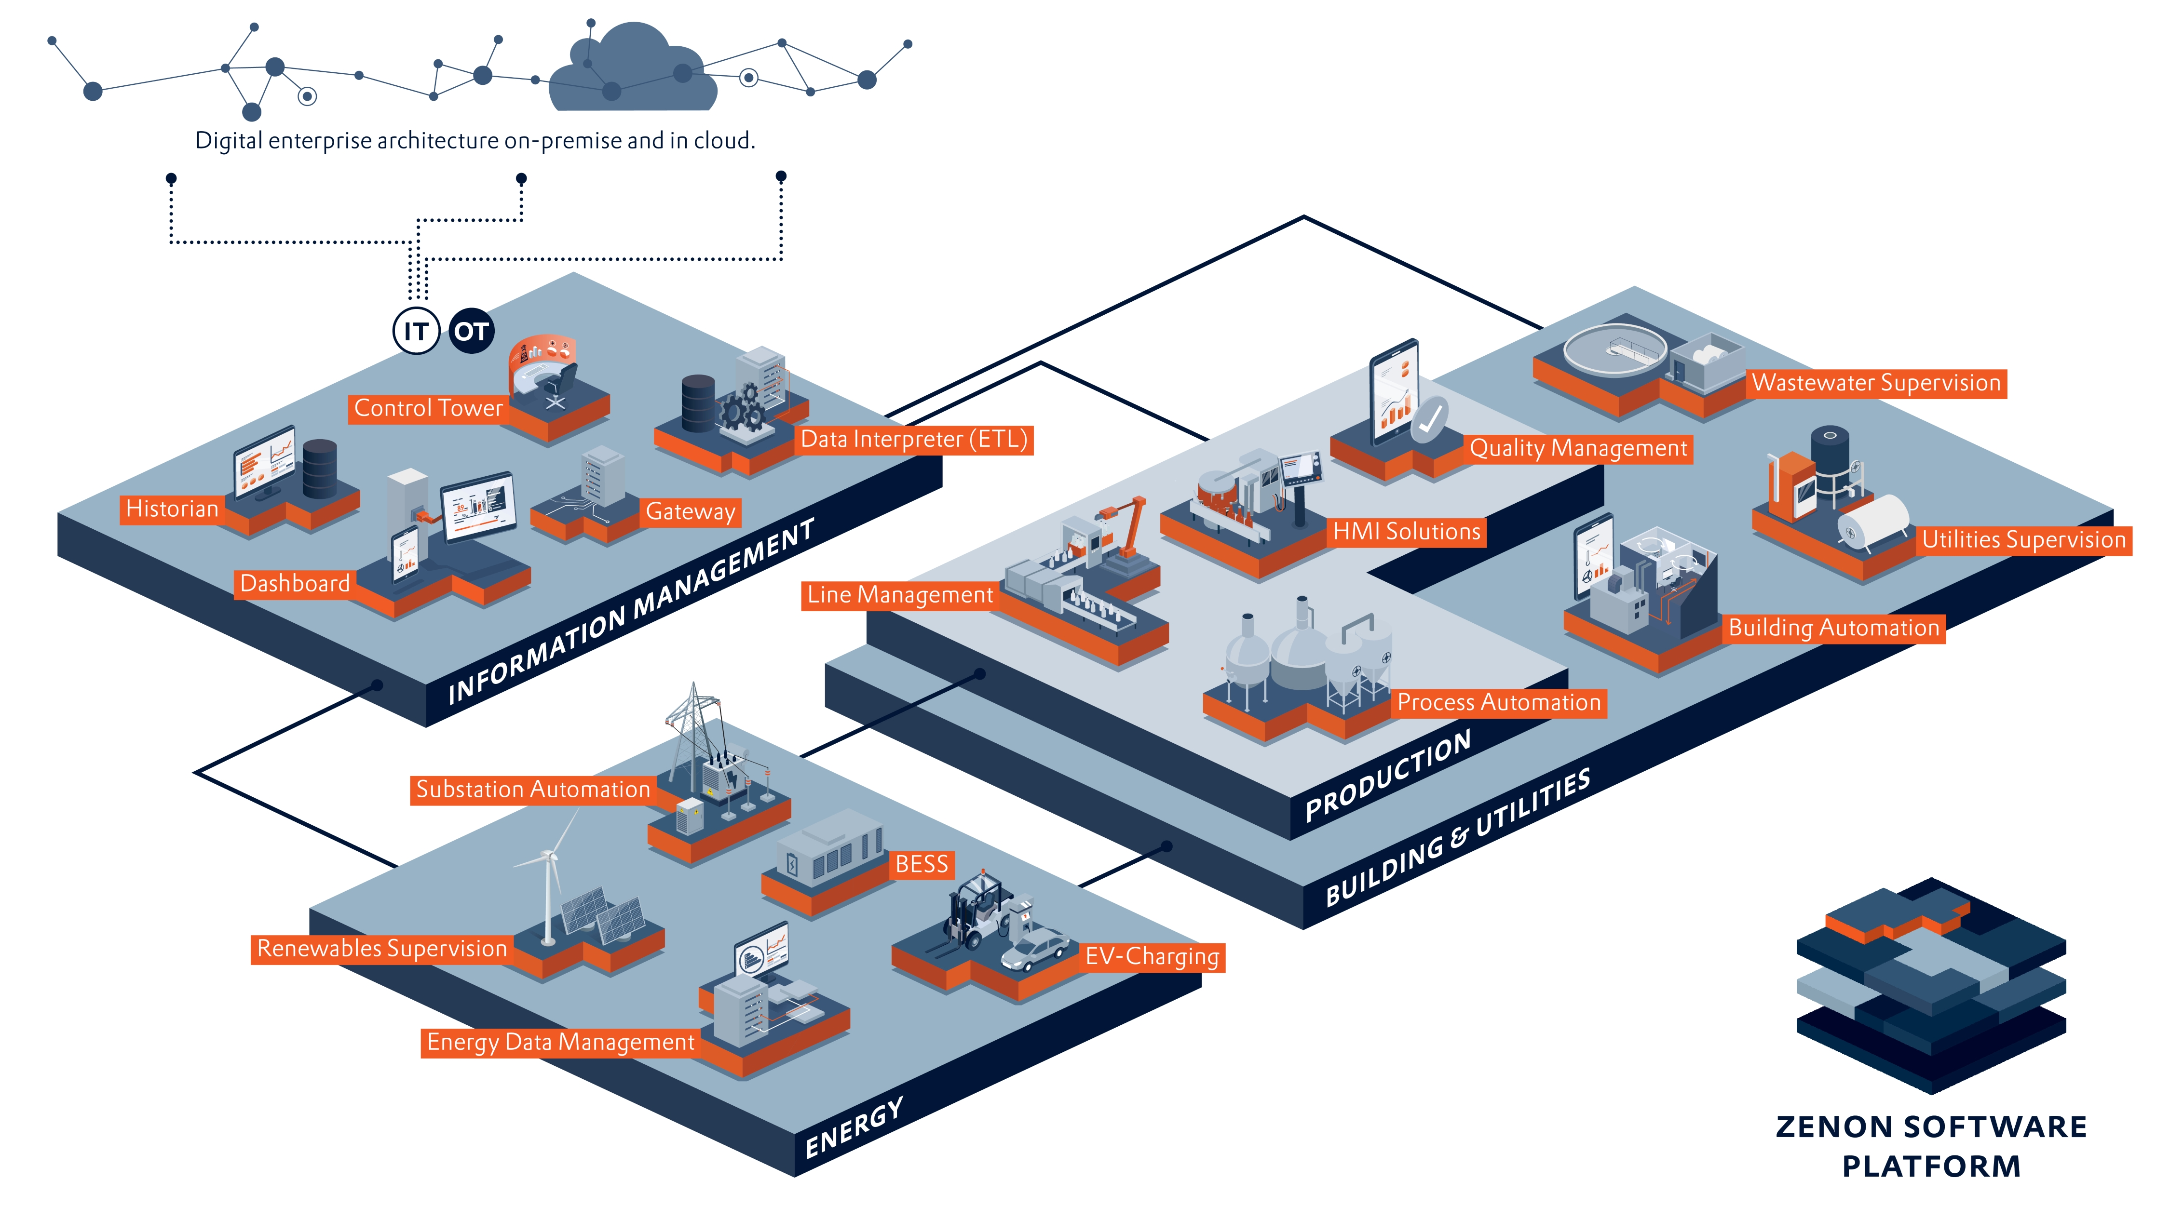The zenon software platform offers versatile possibilities for the beverage industry.

Picture credit: COPA-DATA

Your contact persons

COPA-DATA Headquarters

Michaela Hasslacher  
Public Relations Manager  
T: +43 662 431002-242  
[michaela.hasslacher@copadata.com](mailto:samuel.inwinkl@copadata.com)

Ing. Punzenberger COPA-DATA GmbH

Karolingerstrasse 7b

5020 Salzburg

Austria

[press@copadata.com](mailto:press@copadata.com)

[www.copadata.com](http://www.copadata.com)

](https://www.instagram.com/copadata_insights/)[\\copa-data.internal\shares\User\Julia Angerer\Documents\Social Media\facebook.png](https://www.facebook.com/COPADATAHeadquarters)[\\copa-data.internal\shares\User\Julia Angerer\Documents\Social Media\youtube.png](http://www.youtube.com/user/copadatavideos)[\\copa-data.internal\shares\User\Julia Angerer\Documents\Social Media\linkedin.png](https://www.linkedin.com/company/copa-data-headquarters)

Stone Junction

Rebecca Snow

Account manager

Stone Junction Ltd

Water Street, Suites 1&2, The Malthouse

Stafford, Staffordshire, ST16 1AR

United Kingdom

T: +44 1785 225416

[becky@stonejunction.co.uk](mailto:becky@stonejunction.co.uk)

[www.stonejunction.co.uk](http://www.stonejunction.co.uk)