Salzburg, February 2, 2026
Software manufacturer COPA-DATA increases turnover by 21 per cent
Austria-based software specialist COPA-DATA once again achieved significant turnover growth in 2025 — an increase of 21 per cent over 2024. This continues a multi-year growth trend and is also reflected in the number of employees: across the group, COPA-DATA hired 40 new employees in 2025. The family business, founded in 1987, is thus positioning itself for the future.
"The economic environment is challenging worldwide, and our customers are feeling the effects," says Phillip Werr, Member of the Management Board at COPA-DATA. "We are delighted that we are supporting them to become more competitive in this environment and to master complex challenges. In 2025, we once again achieved double-digit sales growth." As a manufacturer of automation software for industry and the energy sectors, COPA-DATA serves a future-focused market driven by global trends — particularly automation and digitalization, a shortage of skilled workers and sustainability and renewable energy. This is further driven by the need to stay competitive, especially in high‑wage countries.
New Salzburg office building
In 2025, COPA-DATA decided to expand its office facilities at its headquarters in Salzburg. Completion is planned for 2027. "We need the space because the demand for our software solutions will continue to grow," says Werr. "We will continue to invest in Salzburg as a research and development hub." Reflecting sustained expansion, COPA‑DATA added 40 employees in 2025, increasing its worldwide headcount to 500, a number that has grown steadily in recent years. "I would like to thank the team that serves our customers every day. Without their passion, commitment and constant willingness to learn, our success would not be possible," emphasizes Thomas Punzenberger, Chief Executive Officer (CEO) and founder of the company.
Recognized as an innovation leader
COPA-DATA has been an Associate Partner of the World Economic Forum (WEF) since 2024. The software manufacturer is currently one of only three Austrian companies represented at the WEF. In addition to the well-known annual meeting in Davos, Switzerland, the WEF holds events throughout the year. "We have made a name for ourselves at the World Economic Forum as an innovation leader," says Stefan Reuther, Member of the Management Board at COPA‑DATA. "We focus on digitalization and sustainability and deploy state‑of‑the‑art technologies, with renowned references worldwide." COPA‑DATA also participated in more than 50 trade fairs and industry events worldwide in 2025.
Networking event zenonIZE in Salzburg
Another highlight of the past year was the zenonIZE sales event in early October 2025. Over 500 international customers and partners attended COPA‑DATA's event in Salzburg, the city of Mozart. The two-day knowledge forum, which included networking opportunities, was held under the motto "Composing Tomorrow: Automatize, Digitalize, zenonIZE". It was the software company's largest networking event to date. The central theme — the future of automation — was explored in keynotes, panel discussions and workshops. The "COPA-DATA Partner Community Awards" were also presented for the first time, recognizing particularly successful system integrators — partners — from the manufacturing and energy sectors. "The feedback on zenonIZE was excellent," says Reuther. "Our customers left inspired."

Pictures
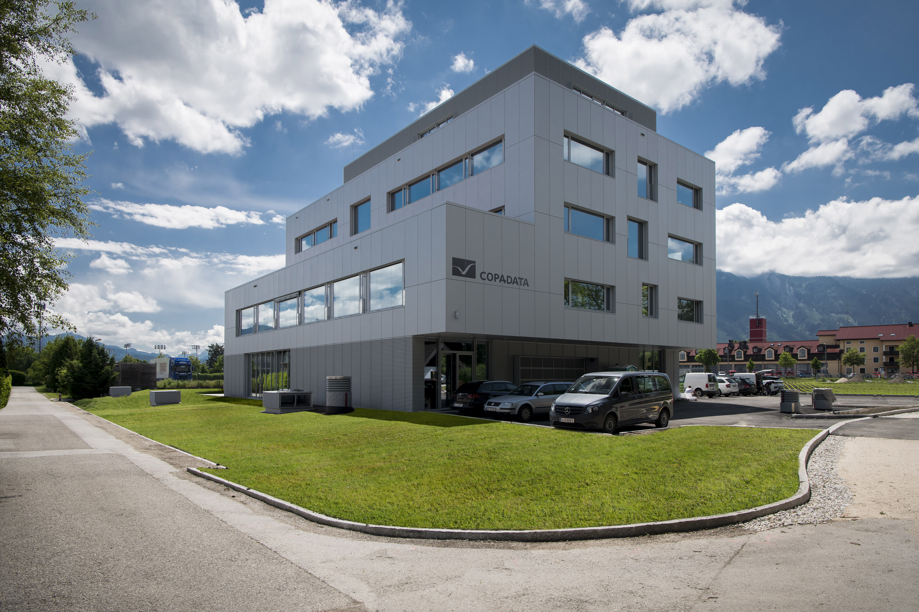
Picture credits: COPA-DATA / Florian Mitterer
The software company COPA-DATA achieved 21 percent turnover growth in 2025 and is expanding its Salzburg headquarters.

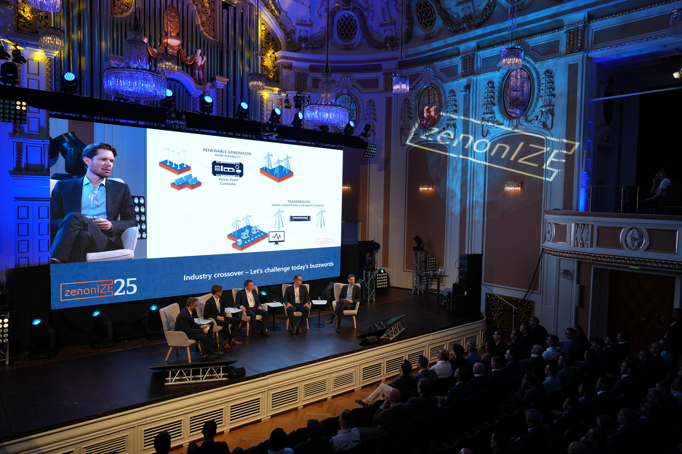
Picture credits: COPA-DATA
Over 500 international customers and partners attended the zenonIZE networking event in Salzburg in October.

About COPA-DATA
COPA-DATA is an independent software manufacturer that specializes in digitalization for the manufacturing industry and energy sector. Its zenon software platform enables users worldwide to automate, manage, monitor, integrate and optimize machines, equipment, buildings and power grids. COPA-DATA combines decades of experience in automation with the potential of digital transformation and a strong drive for solutions that achieve greater sustainability. In this way, the company supports its customers to achieve their objectives more easily, faster and more efficiently. The family-owned business was founded by Thomas Punzenberger in 1987 in Salzburg, Austria.

Your contact persons
Michaela Hasslacher
Public Relations Manager
T: +43 662 431002-242
michaela.hasslacher@copadata.com
Sebastian Bäsken
Team Lead Communication & Brand
T: +43 662 431002-345
sebastian.baesken@copadata.com

Ing. Punzenberger COPA-DATA GmbH
(COPA-DATA Headquarters)
Karolingerstrasse 7b
5020 Salzburg, Austria
www.copadata.com




