Salzburg, March 18, 2026
interpack 26: COPA-DATA presents automation software for transformation
The process and packaging industry is changing, and developments such as digitalization, increasing regulatory requirements and changing consumer behavior are challenging producers, machine builders and system integrators. Software manufacturer COPA-DATA will be presenting its zenon software platform at interpack, the Düsseldorf trade fair for packaging, from May 7 to 13, 2026. The company will be demonstrating how process automation supports transformation within the industry in hall 8B, booth D31.
How can digital change succeed? "At our booth, we will demonstrate how our software technology helps to overcome challenges relating to flexibility, performance, data integrity and quality in production," says Emilian Axinia, Director Digitalization and Machinery at COPA-DATA. The international software company with headquarters in Austria, founded in 1987, addresses a broad audience at interpack – from machine builders and system integrators to IT managers in manufacturing companies. "We will highlight how easily and flexibly the modular structure of our zenon software platform interacts with process automation," continued Axinia. zenon is a no-code or low-code platform that supports international standards such as Modular Type Package (MTP), OMAC PackML or Weihenstephan.
Focus on smart manufacturing
In line with the theme of the trade fair, COPA-DATA will focus on "Smart Manufacturing". zenon provides support on the path to Industry 4.0 by integrating machines and equipment into digitalization solutions via numerous standardized data interfaces – across factories and beyond. This allows production data to be collected, monitored and analyzed in a future-oriented manner. This opens up opportunities for machine manufacturers and original equipment manufacturers (OEMs) in particular: digital twins, orchestrated production lines, predictive maintenance and real-time analyses of overall system effectiveness are becoming a reality. This creates data-driven production environments that make efficiency losses visible and enable optimization.

Live demos at the trade fair booth
With live demos of the current version of zenon, COPA-DATA turns abstract concepts into a reality. For example, the trade fair team will demonstrate the Human Machine Interface (HMI) of its software platform – a feature that is particularly relevant to OEMs. The interface for visualization and control is also suitable for both the life science and food and beverage sectors, as it can be adapted to their respective requirements. COPA-DATA will also present solutions for modular production. These support Plug & Produce, for example, and help to adapt industrial processes quickly. Visitors to the booth will also be able to learn more about current requirements relating to compliance and regulations as well as sustainability in the process industry. The team will also discuss the integration and modernization of legacy systems.
Success stories from the field
Last but not least, COPA-DATA's booth partner, system integrator ControlTech Engineering AG (CTE), will report on success stories from the field. "CTE is an experienced top service provider that understands the requirements of its customers," says Axinia. CTE is a Gold Partner in the COPA-DATA Partner Community (CDPC) and therefore at the highest level of the established system integrator network.

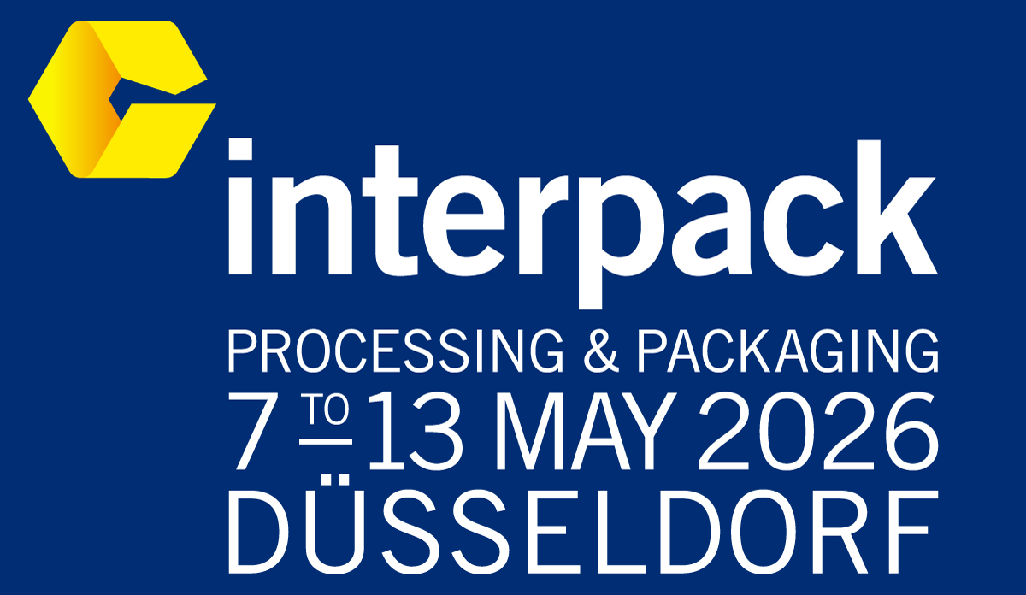
Images
Logo interpack

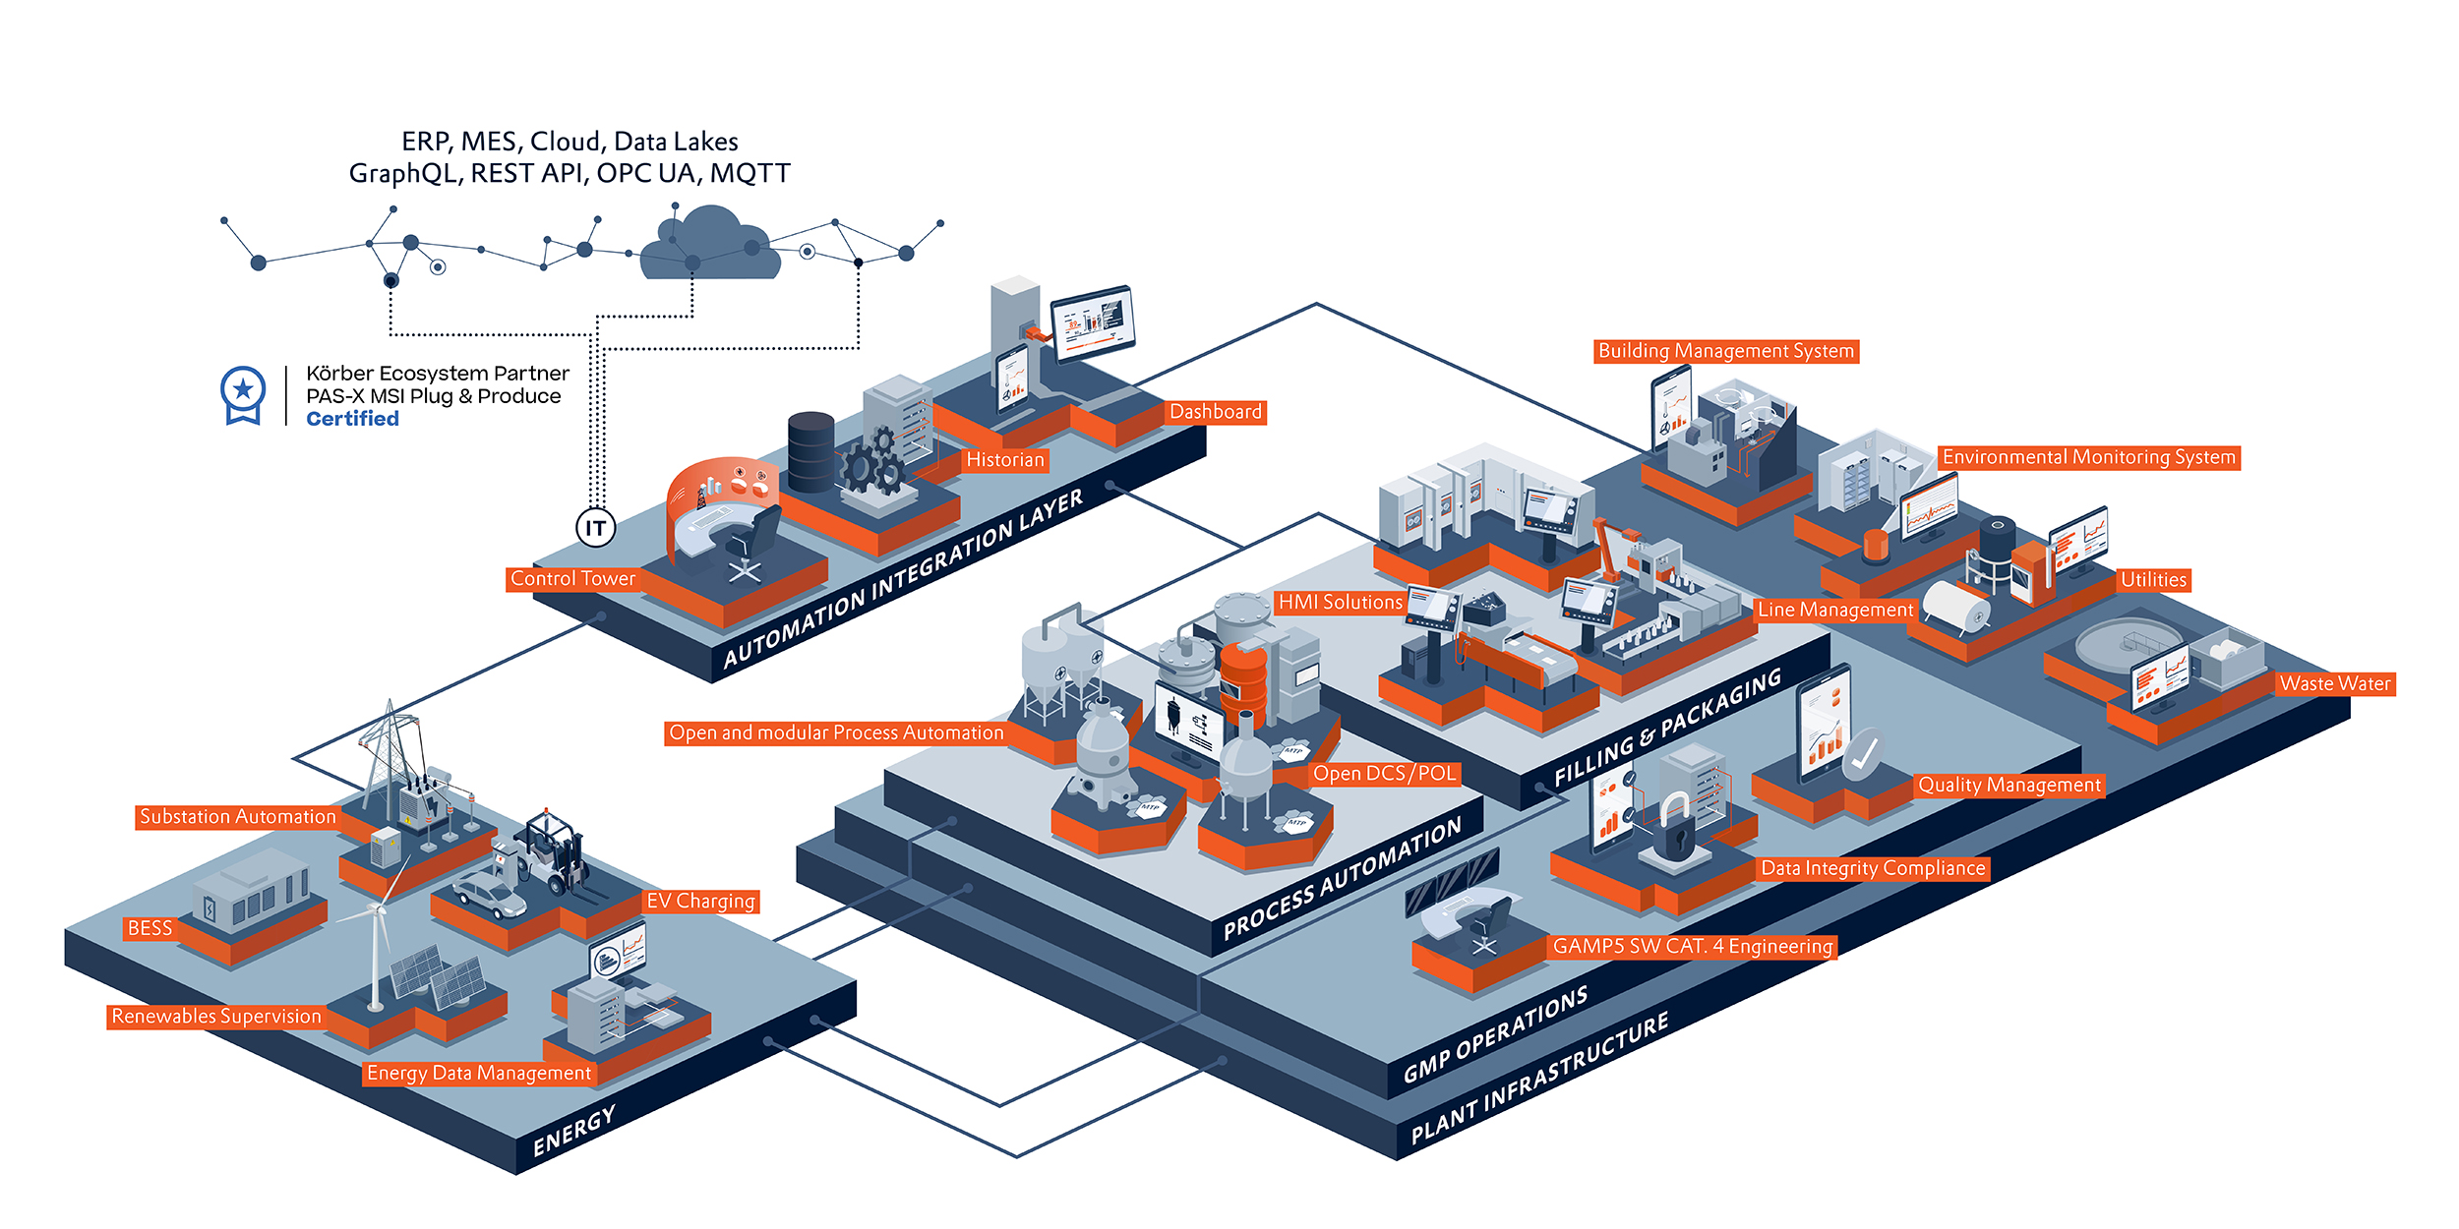

Picture credit: COPA-DATA
In May, COPA-DATA will be demonstrating at interpack in Düsseldorf how versatile the zenon software platform is in the process industry.
About COPA-DATA
COPA-DATA is an independent software manufacturer that specializes in digitalization for the manufacturing industry and energy sector. Its zenon software platform enables users worldwide to automate, manage, monitor, integrate and optimize machines, equipment, buildings and power grids. COPA-DATA combines decades of experience in automation with the potential of digital transformation and a strong drive for sustainability-enabling solutions. In this way, the company supports its customers to achieve their objectives more easily, faster and more efficiently. The family-owned business was founded by Thomas Punzenberger in 1987 in Salzburg, Austria.

Your contact person
Michaela Hasslacher
Public Relations Manager
T: +43 662 431002-242
michaela.hasslacher@copadata.com
Ing. Punzenberger COPA-DATA GmbH
(COPA-DATA Headquarters)
Karolingerstrasse 7b
5020 Salzburg, Austria
www.copadata.com

