Press release
Salzburg, July 30, 2026
Digitalization: more space for research and development in Salzburg, Austria
Global demand for digitalization solutions in industry and the energy sector continues to grow. COPA-DATA is addressing this demand with its zenon software platform. Key drivers include industrial digitalization, the need for resilient supply chains, and the sustainable expansion of the energy sector. Skills shortages in these industries and the drive to remain competitive in high-wage economies are further accelerating this trend.

To support its continued growth, the Austrian company COPA-DATA is expanding its “COPA-DATA Headquarters” in Salzburg, creating space for up to 150 additional employees. The company is investing €15 million in the project, underlining its long-term commitment to Salzburg and Austria as a location for technology, research and innovation.

Planning permission for the new building in Salzburg was recently granted. It will be directly connected to the existing building, which opened in 2022. The completion is scheduled for the third quarter of 2027, coinciding with the 40th anniversary of the independent, family-owned software company, which has its roots in Salzburg. The expansion reflects the continued growth of the company and its international operations.

Continued growth
COPA-DATA continues to attract new customers around the world. In 2025, the software developer recorded revenue growth of more than 20 percent. Its workforce is also steadily expanding and now comprises more than 500 employees worldwide. Of these, 270 work at the Salzburg headquarters, around half of them in research and development.

“Innovation in the digital world also depends on personal interaction. That is why we are continuing to invest in our Salzburg location, where we conduct research and development for customers and markets worldwide,” says Phillip Werr, Member of the Executive Board. “Our software serves key future markets, supporting the expansion of renewable energy and modern, sustainable manufacturing. By expanding our innovation hub, we are creating the capacity needed to meet this growing demand.”

Salzburg as technology hub
“By expanding our headquarters, we are reaffirming our commitment to Salzburg as a center for research and development,” emphasizes Thomas Punzenberger, Chief Executive Officer (CEO) and Founder. Since founding the company in 1987, he has believed in Salzburg’s potential as a technology hub: “Salzburg offers an attractive location and an exceptional quality of life and is therefore attracting skilled professionals from Austria and abroad.”

For COPA-DATA, providing employees with an attractive and supportive working environment is essential to fostering innovation, supporting each employee’s personal development, and retaining talent over the long term.

A modern working environment
In addition to energy efficiency, the planning of the new office building focused on creating a working environment that encourages innovation, collaboration and interaction.

“The existing building is not simply being extended. Instead, we are creating an ensemble of distinct building volumes, each with its own architectural identity. Together, they will enclose a sheltered courtyard that serves as the development’s central outdoor space,” says architect Gerhard Sailer. Sailer and his Salzburg-based architectural office HALLE 1 designed the new building, having also designed the company’s existing headquarters in Salzburg.

The new building
The expansion, comprising a reception pavilion and an additional office building, will cover approximately 3,000 square meters. Workspaces will be designed flexibly to accommodate the dynamic growth and changing needs of the various teams, while an atrium will provide ample natural light.

The plans also include a spacious customer area, employee lounges and a fitness room. Employees who cycle to work will have access to extensive covered bicycle parking, changing rooms and showers.

A smart and sustainable building
The building will be heated and cooled using an energy-efficient system combining geothermal energy with thermally activated building components. Integrated photovoltaic elements are also planned for the façade. As in the existing buildings, building automation will be managed using the company’s own zenon software platform. This will transform the premises into a smart building in which heating, air conditioning, ventilation, shading, lighting, energy generation and energy consumption are integrated into one intelligent system.

The apprentices trained by COPA-DATA continuously contribute to the development of the building automation system, gaining valuable hands-on experience in the process. In this way, the new building will also serve as a practical showcase for the company’s technology and sustainable digitalization approach.

Captions
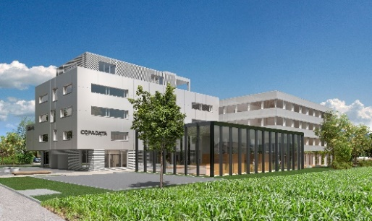
Download – image credit: AVISU
Visualization of the building ensemble in Salzburg: the existing building on the left, the new office building in the background, and the reception pavilion in front.
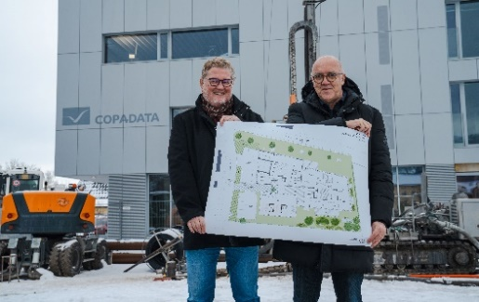
Download – image credit: COPA-DATA / Moritz Aichriedler
Thomas Punzenberger (left), founder and Chief Executive Officer of COPA-DATA, and architect Gerhard Sailer of HALLE 1 present the floor plan of the building ensemble.

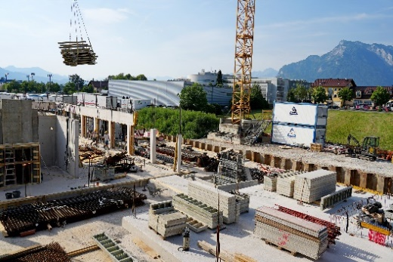
Download – image credit: COPA-DATA
The construction site in Salzburg, Austria.

View the construction site webcam

About COPA-DATA

COPA-DATA is an independent software manufacturer specializing in the digitalization of the manufacturing and energy industries. Its Softwareplattform zenon is used worldwide to automate, control, monitor, connect, and optimize machinery, production facilities, buildings, and power grids. COPA-DATA combines decades of experience in automation with the opportunities offered by digital transformation and a strong commitment to developing solutions that deliver greater sustainability. In doing so, the company helps its customers achieve their goals more easily, quickly, and efficiently.

Your contact person
Michaela Hasslacher
Public Relations Manager
michaela.hasslacher@copadata.com
Tel.: +43 662 431 002-242
Mobil: +43 664 888 97 659
Ing. Punzenberger COPA-DATA GmbH
COPA-DATA Headquarters
Karolingerstrasse 7B
5020 Salzburg
Austria
www.copadata.com


